Name

Mathematics Stage 4
Length

Book 1 |  | Version: 260909  Feedback:  https://MrDingMaths.com
Contents
Syllabus Content 2
Learning Intention 3

Syllabus Content
MA4-LEN-C-01 applies knowledge of the perimeter of plane shapes and the circumference of circles to solve problems
Solve problems involving the perimeter of various quadrilaterals and simple composite figures
- Solve problems involving the perimeter of plane shapes, including parallelograms, trapeziums, rhombuses and kites
- Solve problems relating to the perimeter of simple composite figures
- Compare methods of solution for finding perimeter and evaluate the efficiency of those methods
Describe the relationships between the features of circles
- Identify and describe the relationship between circle features, including the radius, diameter, arc, chord, sector and segment of a circle, and a tangent to a circle
- Define $π$ as the ratio of the circumference to the diameter of any circle
- Verify that the number $π$ is a constant and develop the formula for the circumference of a circle
- Apply the formula for the circumference of a circle in terms of the diameter $d$ or radius $r$ (circumference of a circle $C=πd$ or $=2πr$) to solve related problems to solve related problems
- Establish the arc length formula $l=\frac{θ}{360}×2πr$ where $l$ is the arc length and $θ$ is the angle subtended at the centre by the arc
- Solve problems by finding arc lengths and the perimeter of sectors, giving an exact answer in terms of $π$ or an approximate answer
- Find the perimeter of quadrants, semicircles and simple composite figures consisting of 2 shapes in a variety of contexts, including using digital tools

Units of Length

- Review
- Multiply each number by 10
- $37×10$ | - $0.37×10$ | - $307×10$
- $30.7×10$ | - $3.07×10$ | - $0.0307× 10$

- Multiply each number
- $46×100$ | - $4.06×100$ | - $406×100$
- $460×100$ | - $4.6×1000$ | - $4.06×1000$
- $10×4.006$ | - $100×46$ | - $1000×0.46$

- Divide each number by 10
- $37÷10$ | - $0.37÷10$ | - $307÷10$
- $30.7÷10$ | - $3.07÷10$ | - $0.0307÷ 10$

- Divide each number
- $46÷100$ | - $4.06÷100$ | - $406÷100$
- $460÷100$ | - $4.6÷1000$ | - $4.06÷1000$
- $4.006÷10$ | - $46÷1000$ | - $460÷1000$

  - Measure the length of your table using your handspan. How many handspans?
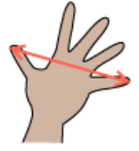
  - What might be the issue with using handspans to measure things?

- Units of Length
- A metre (m) is the basic metric unit used to measure length.
Door handles are about 1 m off the ground.
- All other metric units are related to the metre by powers of 10.
  - 1 kilometre (km) = 1000 metres (m)
  - 1 metre (m) = 100 centimetres (cm)
  - 1 centimetre (cm) = 10 millimetres (mm)
- We have different units of length to avoid using very small or very large numbers.

- Identify most appropriate unit of length
Cirlce the most appropriate unit to measure these things.
- Length of a swimming pool mm cm m km

- Length of a ruler mm cm m km

- Length of an ant mm cm m km

- Height of an apartment building mm cm m km

- Length of a tennis court mm cm m km
- Distance Sydney to Melbourne mm cm m km
- Length of a school desk mm cm m km
- Height of a skyscraper mm cm m km
- Width of a leaf mm cm m km
- Height of a person mm cm m km

- Converting Units of Length
- When converting to a smaller unit, multiply.
A smaller unit means you need more of them, so you multiply.

- When converting to a larger unit, divide.
A larger unit means you need less of them, so you divide.
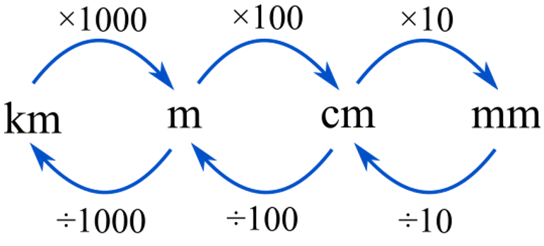

- Example Convert units of length
400 cm to m  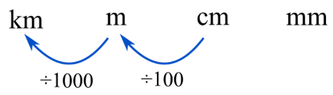  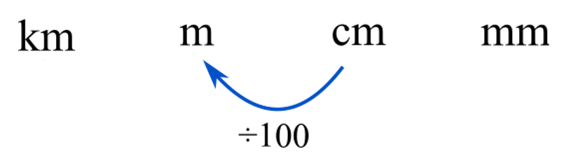  $400 cm÷100$  $=4$m | 738 000 cm to km  $738 000 cm÷100÷1000$  $=7.38$ km | 0.808 m to mm  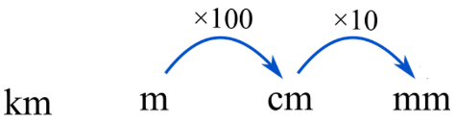  $0.808 m×100×10$  $=808 mm$

- Guided Practice
Convert these lengths to the given unit.
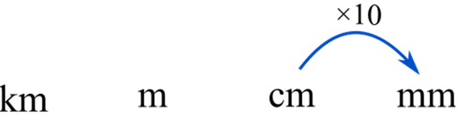  - 5 cm to mm  50 mm | 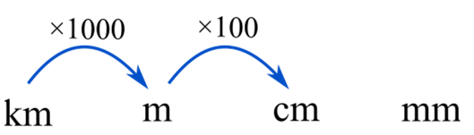  - 2.3 km to cm  230 000 cm | - 35 cm to m  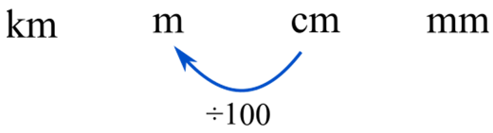  0.35 m
- 2.1 m to mm  2100 mm | - 400 mm to m  0.4 m | - 500 cm to km  0.005 km

- Key Ideas
- A metre is the basic ……………… unit used to measure length.
- Metric units are related to each other based on ………………… of 10.
- When converting to a smaller unit, we ……………………
- When converting to a larger unit, we ……………………..

Foundation
- Convert these units.
- 0.8 m = …… cm  80 | - 1.9 cm = …… mm  19 | - 0.37 m = …… mm  370
- 7.5 cm = …… mm  75 | - 43 cm = …… m  0.43 | - 273 mm = …… m  0.273
- 1.6 m = …… cm  160 | - 0.11 m = …… cm  11 | - 0.673 m = …… cm  67.3
- 30 mm = …… cm  3 | - 0.4 m = …… mm  400 | - 2.03 m = …… cm  203

- Convert these measurements to the required unit.
- 7 m = ……… cm  700 | - 3.7 m = ……… cm  370 | - 30.7 cm = ……… m  0.307
- 70 m = ……… cm  7000 | - 370 m = ……… cm  37000 | - 0.307 cm = ……… m  0.00307
- 0.70 m = ……… cm  70 | - 370 cm = ……… m  3.7 | - 0.0307 cm = ……… m  0.000307
- 0.7 m = ……… cm  70 | - 37 cm = ……… m  0.37 | - 1.0307 cm = ……… m  0.0010307
- 0.07 m = ……… cm  7 | - 307 cm = ……… m  3.07 | - $\frac{1}{2}$ cm = ……… m  0.005
- 3.07 m = ……… cm  307 | - 3007 cm = ……… m  30.07 | - $\frac{1}{2}$m = ……… cm  50

- Convert these units of measurement.
- 300 cm = ……… m  3 | - 4.5 m = ……… mm  4500 | - 15 km = ……… m  15000
- 30 cm = ……… m  0.3 | - 4.5 m = ……… cm  450 | - 1.5 km = ……… m  1500
- 300 mm = ……… m  0.3 | - 0.45 m = ……… cm  45 | - 0.1 km = ……… m  100
- 30 mm = ……… m  0.03 | - 0.05 m = ……… cm  5 | - 0.05 km = ……… m  50

- Express each length in the required units.
- 5 m + 30 cm (m)  $=5$ m + 0.3 m  $=$ ……… m  5.3 | - 430 cm + 400 mm (cm)  $=$ ……… cm + ……… cm  $=$ ……… cm  470 | - 37 cm + 3 m (cm)  $=$ ……… + ………  $=$ ……… cm  337
- 831 cm + 2 km (m)  2008.31 | - 19 cm – 50 mm (mm)  140 | - 574 cm – 40 mm (cm)  570
- 18 m – 370 mm (m)  17.63 | - 10 km – 3380 cm (km)  9.9662 | - 0.091 km – 777 cm (m)  83.23

Development
- Fill in the table.
 | km | m | cm | mm
 | 1 | 1000 | 100 000 | 1000 000
 | 0.001 | 1 | 100 | 1000
 | 0.000 01 | 0.01 | 1 | 10
 | 0.000 001 | 0.001 | 0.1 | 1
 | 0.000 01 | 0.01 | 1 | 10
 | 0.00017 | 0.17 | 17 | 170
 | 0.0017 | 1.7 | 170 | 1700
 | 1.07 | 1070 | 107 000 | 1 070 000
 | 0.07 | 70 | 7000 | 70 000
 | 0.000 07 | 0.07 | 7 | 70
 | 0.000 0007 | 0.0007 | 0.07 | 0.7
 | 0.00025 | $$\frac{1}{4}$$ | 25 | 250
 | 0.001$n$ | $$n$$ | 100$n$ | 1000$n$

- Joe widens a 1.2 m doorway by 50 mm. What is the new width of the doorway, in centimetres?

125 cm
- A ream of 500 sheets of paper is 4 cm thick. How thick is 1 sheet of paper, in millimetres?

40 mm ÷ 500 = 0.08 mm
- Mount Everest is moving with the Indo-Australian plate at a rate of about 10 cm per year.
How many years will it take to move 5 km?

500 000 cm ÷ 10 cm/year = 50 000 years

Mastery
- Adrian is driving a truck 3.4 m high.
He approaches an overpass bridge which has a clearance of 376 cm.
Will Adrian’s truck get under the bridge? If so, how much room does he have to spare?
Give your answer in centimetres.
Since 340 cm < 376 cm, the truck will fit under the bridge.
Room to spare: 376 cm - 340 cm = 36 cm
- Global sea levels are rising on average 37 mm per year.
How many years would it take for the sea level to rise 2 metres?

2000 mm ÷ 37 mm/year = 54.05 years ≈ 54 years
- NAPLAN B
Wooden beams for building house frames can be purchased in a number of lengths.
A hardware store can supply lengths of 850 millimetres, 80 centimetres, 190 centimetres, 0.855 metres and 1.8 metres.
Which wooden beam is the longest?
850 mm = 850 mm
80 cm = 800 mm
190 cm = 1900 mm
0.855 m = 855 mm
1.8 m = 1800 mm
The longest beam is 190 centimetres (1900 mm).
- NAPLAN B
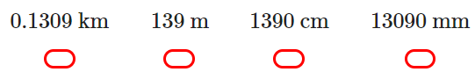
Which of these is the longest distance?
0.1309 km = 130.9 m
139 m = 139 m
1390 cm = 13.9 m
13090 mm = 13.09 m
The longest distance is 139 m.
- NAPLAN B
2 kilometres and 80 metres is the same as
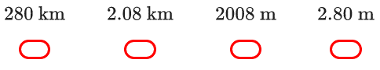
2.08 km.
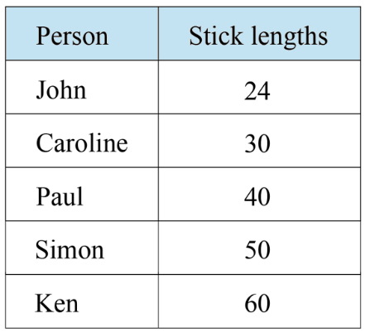
- NAPLAN B+
Five people had sticks of different lengths. Each person measured a 30 metre interval by counting how many stick lengths it took. The results were put into the table.
Who had the stick that was 60 cm long?

Simon, since $3000 cm÷60 cm=50$

Perimeter of Polygons

- Perimeter
- Perimeter is the distance around a two-dimensional (flat) shape.
- To find perimeter, add up the lengths of every side of the shape.
- Words that mean length: dimensions, width, side, breadth, base, height.
- Dashes show equal lengths.

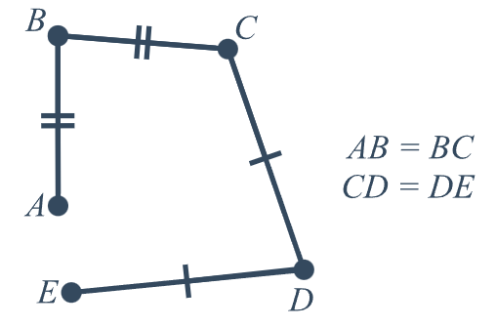
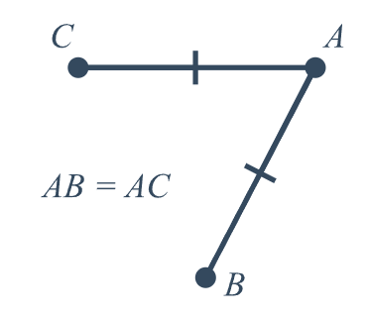

- Example Calculate perimeter of a polygon
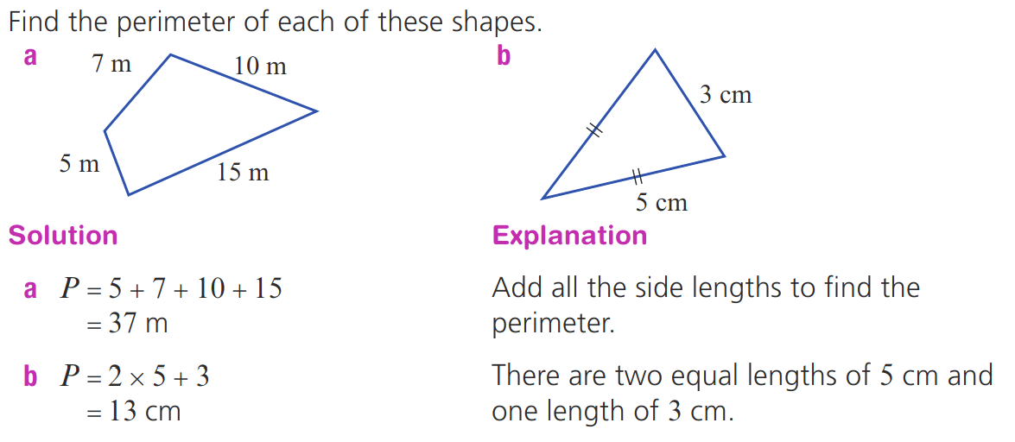  $P=7+10+15+5$  $=37 m$ | $P=5+5+3$  $=13 cm$

- Guided Practice
Calculate the perimeter of these shapes.
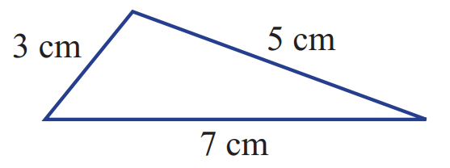  $P=$ …… $+$ …… $+$ ……  $=$ ………… cm  15 cm | 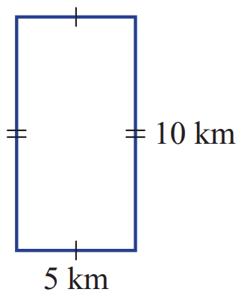  30 km | 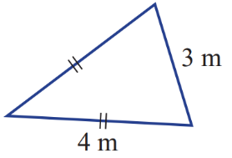  11 m

- Perimeter and Different Units
Units must be the same before you start performing any operations.

- Example Calculate perimeter involving different units
Find the perimeter of the shape.
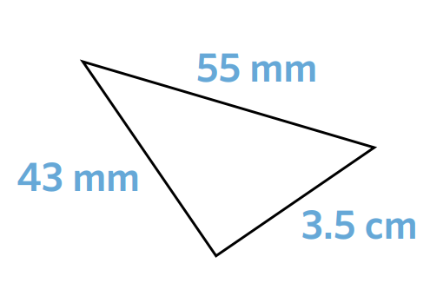
$P=55+43+35$
$=133 mm$

- Guided Practice
Find the perimeter of these shapes. Give your answer in millimetres.
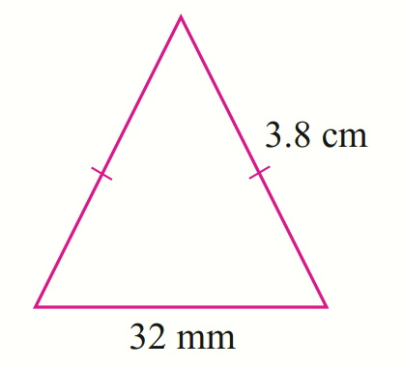  $P=32 mm+$ ……… $mm +$ ……… $mm$  $=$ ……………………  108 mm | 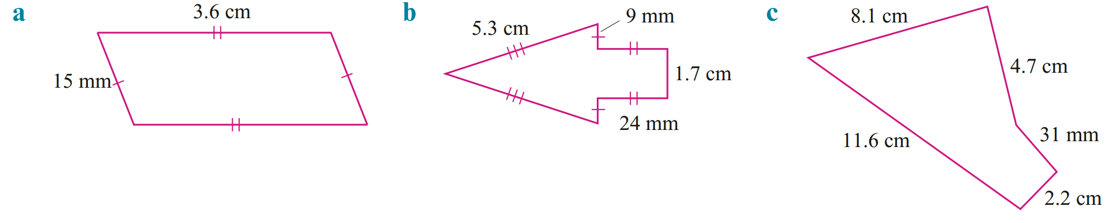  102 mm
189 mm | 297 mm

- Key Ideas
- Perimeter is the distance ………………… a shape.
- Calculate perimeter by …………….… the length of each side.
- Equal lengths are shown using ………….………
- When adding two measurements, we need to ensure that the ……………… are the same.

Foundation
- Calculate the perimeter of these shapes.
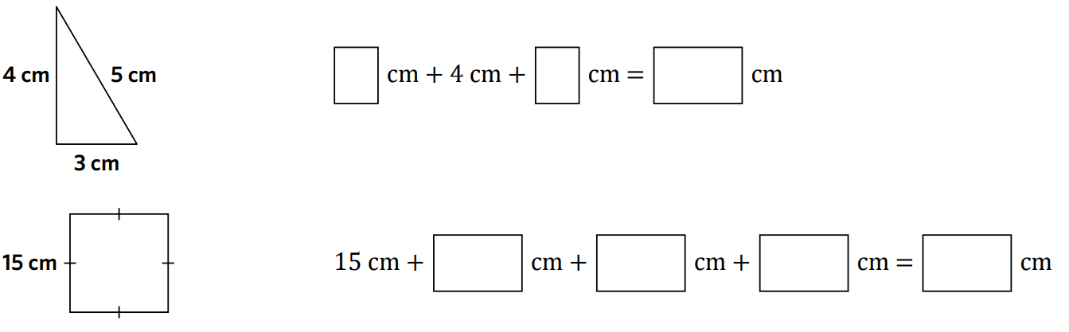  $P=$ …….. $+$ …….. $+$ ……..  $=$ ……… ……  12 cm | $P=$ …….. $+$ …….. $+$ …….. $+$ ……..  $=$ ……… ……  60 cm
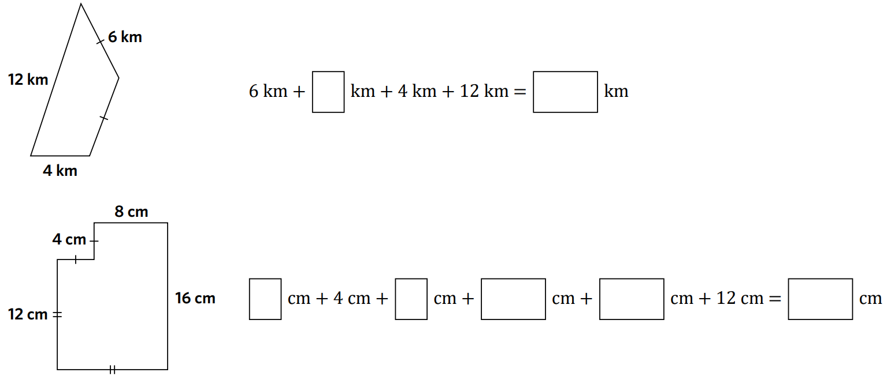  $P=$ …….. $+$ …….. $+$ …….. $+$ ……..  $=$ ……… ……  28 cm | $P=$ …….. $+$ …….. $+$ …….. $+$ …….. $+$ ……..  $=$ ……… ……  56 cm

- Calculate the perimeter of these shapes. Remember to use multiplication for repeated addition.
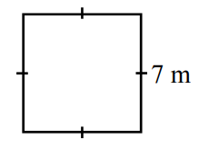  28 m | 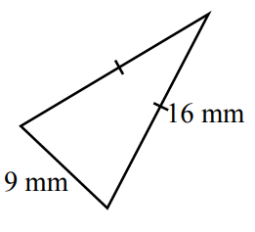  41 mm | 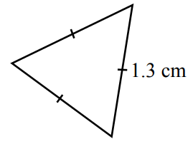  3.9 cm
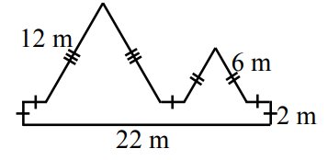  68 m | 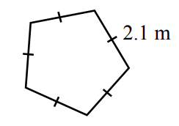  10.5 m | 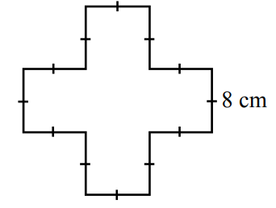  96 cm
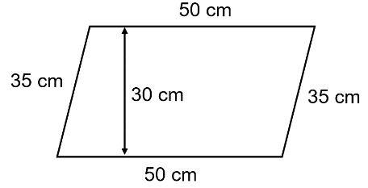  170 cm | 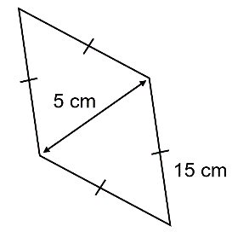  60 cm | - Why is 30 cm and 5 cm not part of the perimeter in parts g and h?  Those lengths are not on the outside of the shape.

Development
- Calculate the perimeter of these rectangles.
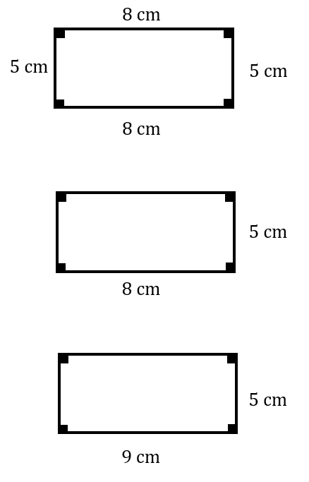  26 cm | 26 cm | 28 cm
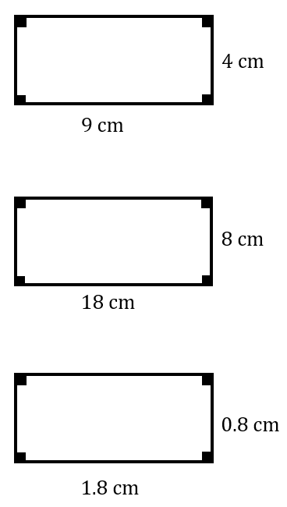  26 cm | 52 cm | 5.2 cm
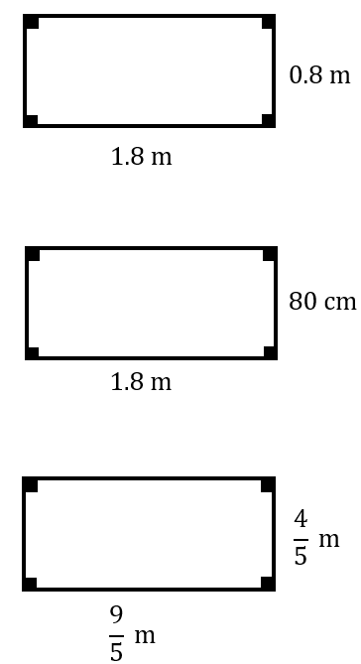  5.2 m | 5.2 m | $$\frac{26}{5} m$$

- Calculate the perimeter of these shapes. Give your answer in the smaller unit.
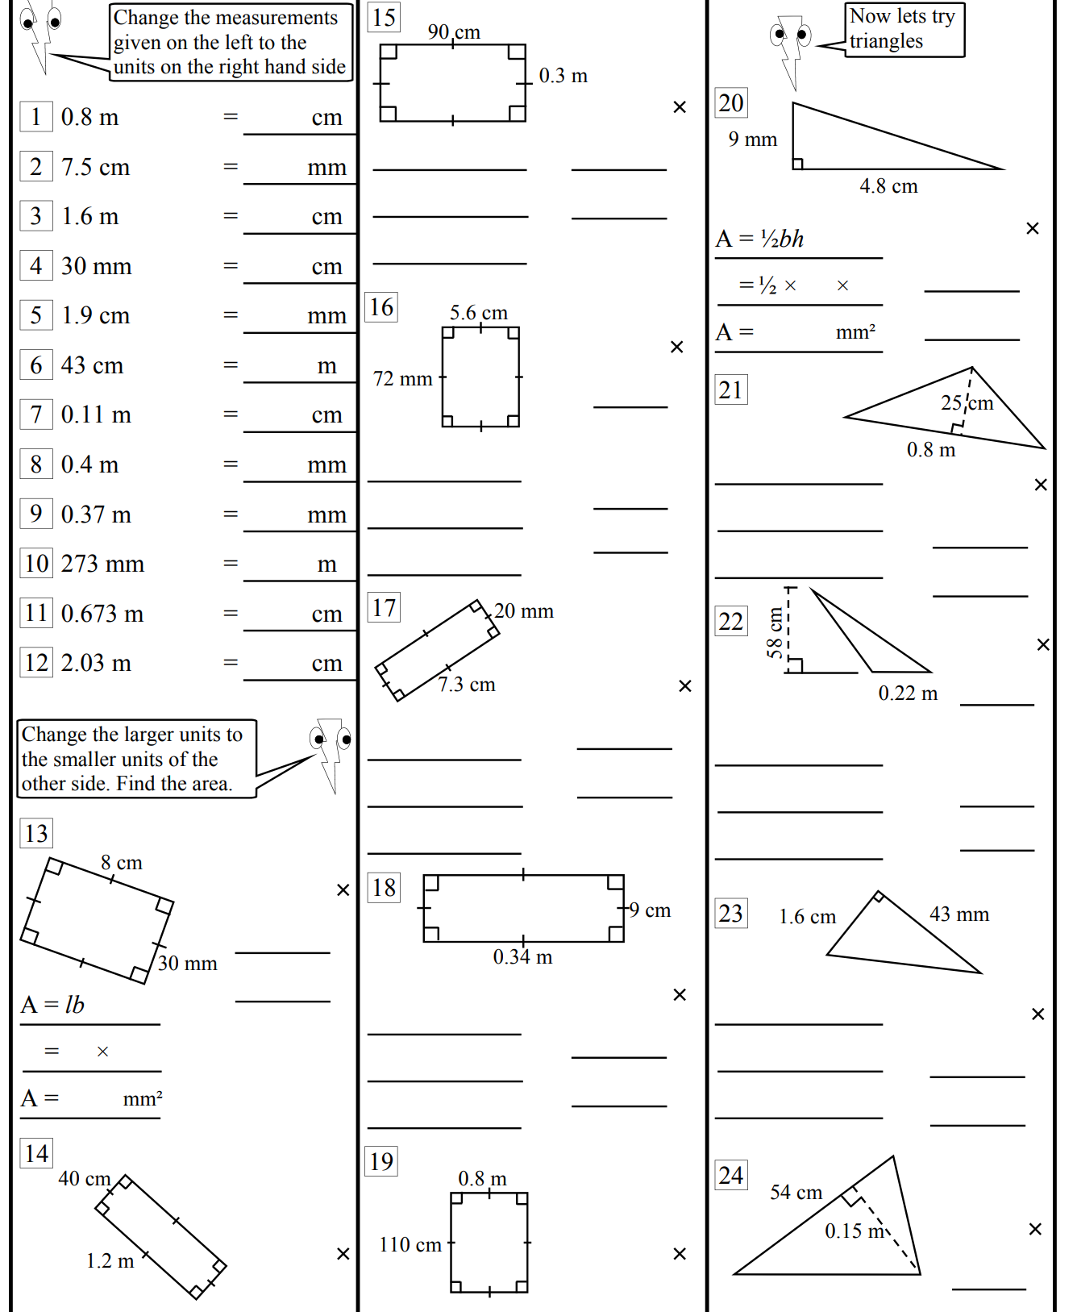  22 cm | 320 cm | 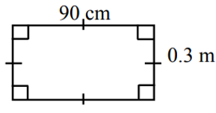  240 cm
- The width of a rectangle is 6.7 cm. Its length is 4.6 cm longer than its width.
Find the perimeter of the rectangle. (Hint: draw a diagram!)

36 cm

- A rectangular swimming pool has sides with lengths 12 m and 4 m.
  - Find the distance around the pool.
32 m
  - A path 1 m wide surrounds the same pool. Calculate the length and breadth of the pool and the path combined, put the dimensions on the diagram below and find the perimeter
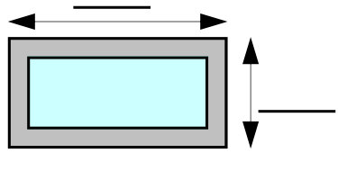

New dimensions are 14 m by 6 m
New perimeter 40 m
  - If the pool has a safety fence around the outside of the path find the cost of fencing the pool when the fence costs $27 per metre

$$40×27=\$1080$$
- A gift is wrapped with two ribbons as shown below.
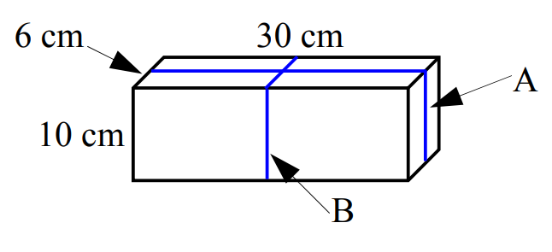
  - Calculate the length of the string A and string B, then add them to find the total length.

112 cm
  - If you wanted to wrap 50 of these gifts the same way, how much ribbon would you need, if 5 cm of ribbon is wasted for each box during the wrapping process?

$50×112+5×50=5850$ cm
- Find the perimeter of each of these shapes. Answer in cm.
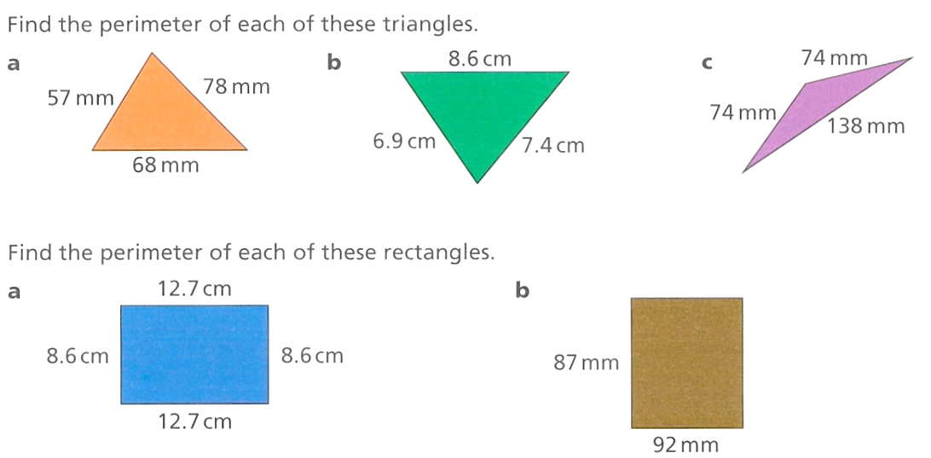  22.9 cm | 42.6 cm | 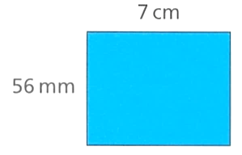  25.2 cm

Mastery
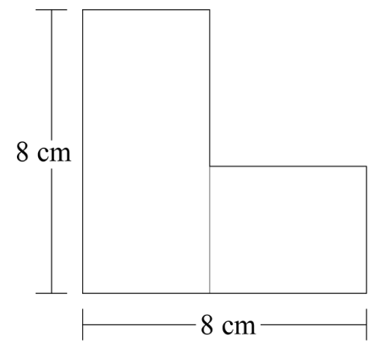
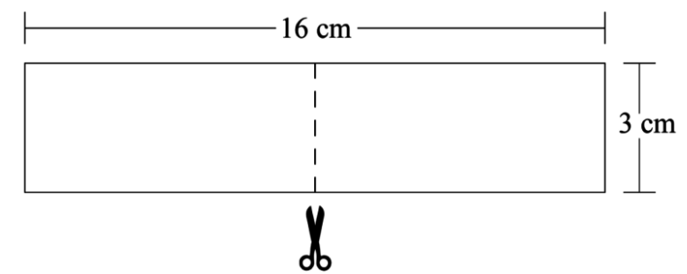
- NAPLAN B+
Pablo cuts a paper rectangle in half. He then places one half over the other to make a new shape. What is the perimeter of the new shape?

32 cm
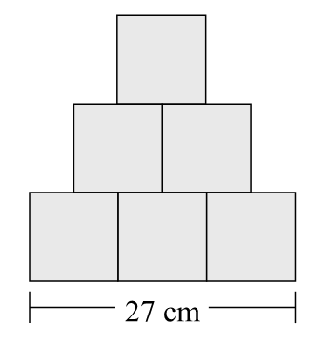
- NAPLAN B+
Penelope made a shape using 6 identical squares. What is the perimeter of the shape?

108 cm

Perimeter of L-shapes

- Review
- Identify the missing length
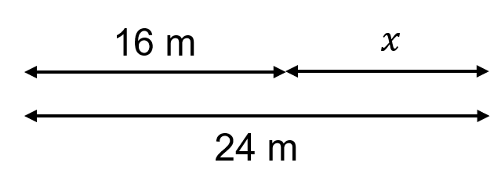 | 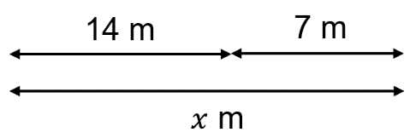
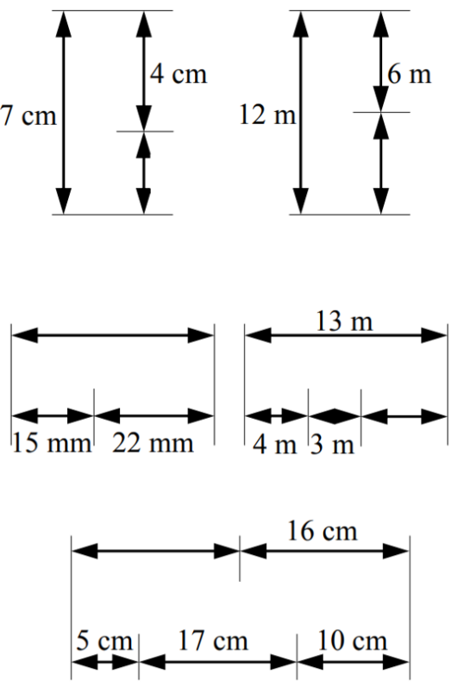

 | 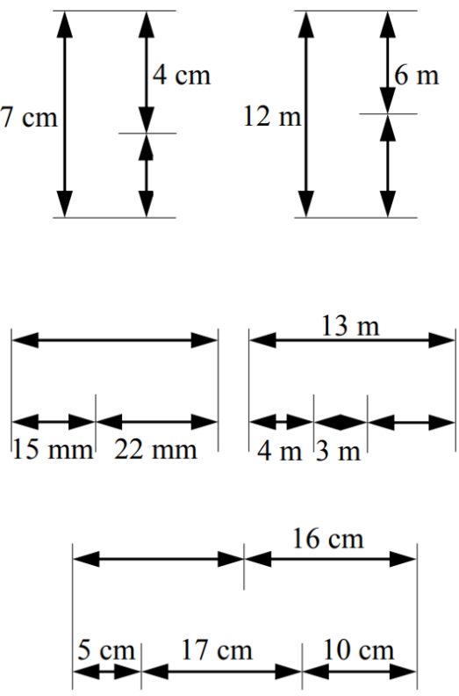

- L-shapes
L-shapes have only straight lines and right angles.
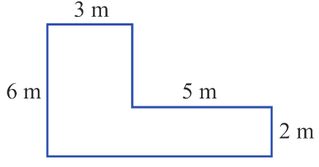

We can find missing sides by looking at the sum of lengths on the opposite side.

- Identify unknown lengths
Label the unknown side indicated by the star in each of these shapes.
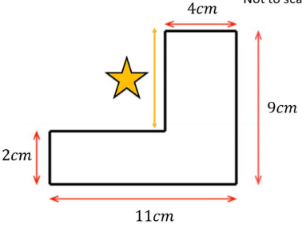 | 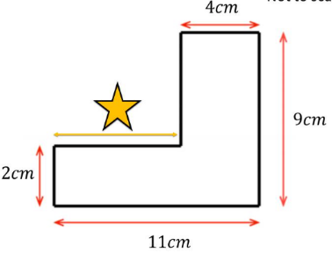 | 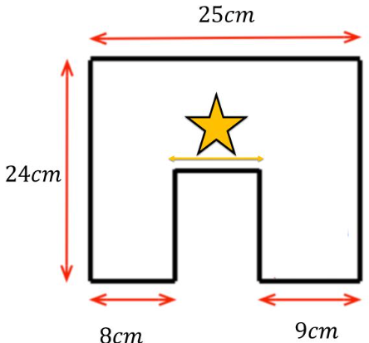
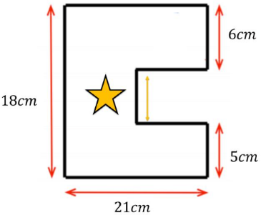 | 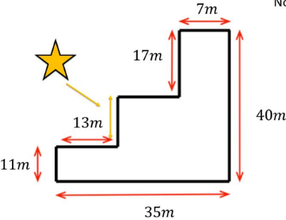 | 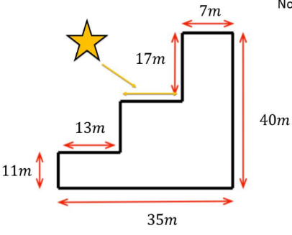

- Example Calculate perimeter of shapes involving right angles and straight lines
Label all sides of this shape then calculate its perimeter.
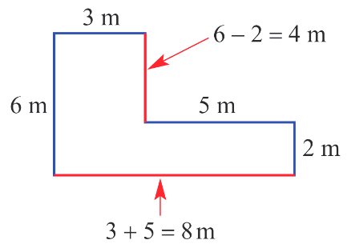

$P=3+4+5+2+8+6$
$=28$m

- Guided Practice
Find the perimeter of each of these L shapes.
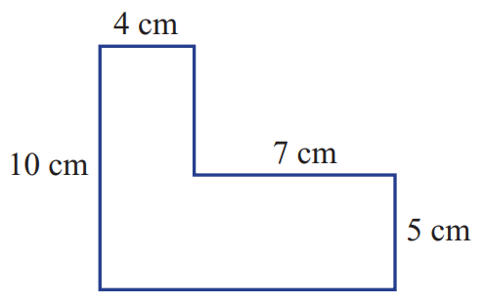

42 cm
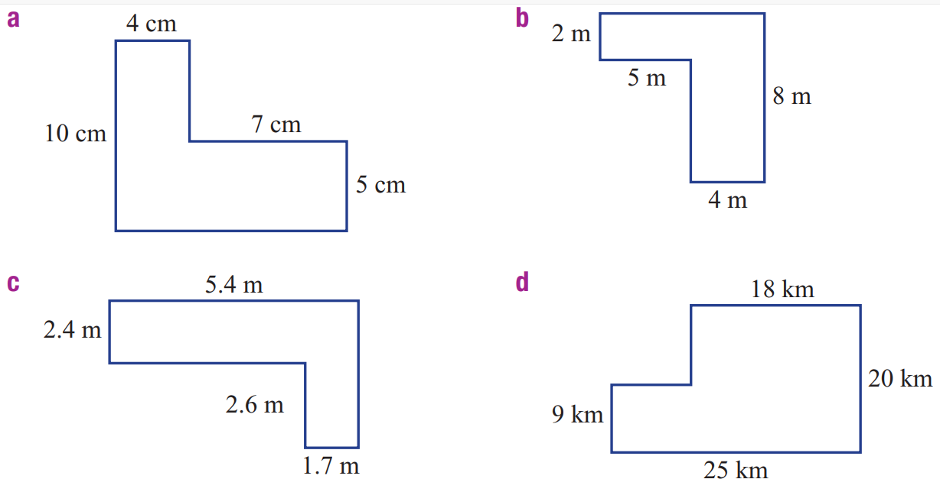

34 cm

20.8 cm

Foundation
- Calculate the perimeter of each of these shapes.
94 m | 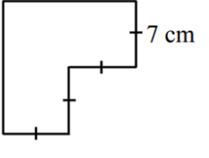  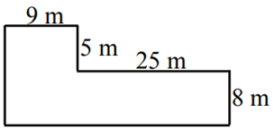  56 cm | 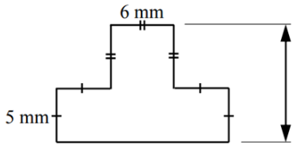  54 cm
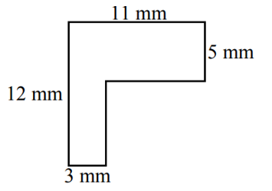  46 mm | 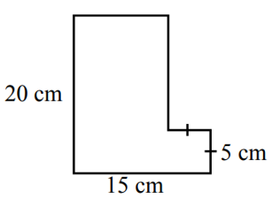  70 cm | 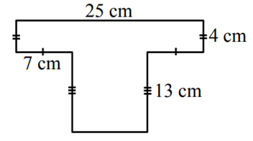  84 cm
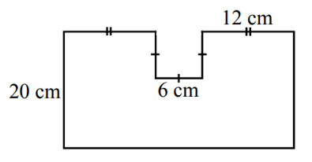  112 cm | 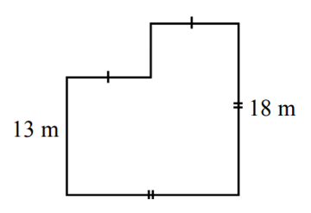  72 cm | 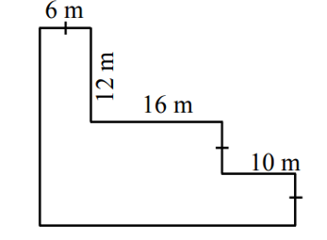  112 cm

- Calculate the perimeter of these shapes. All measurements are in cm.
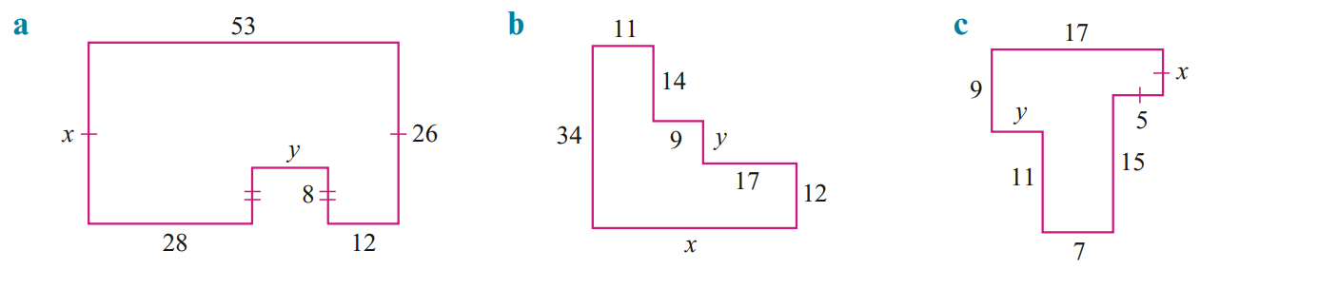  174 cm | 142 cm | 74 cm

Development
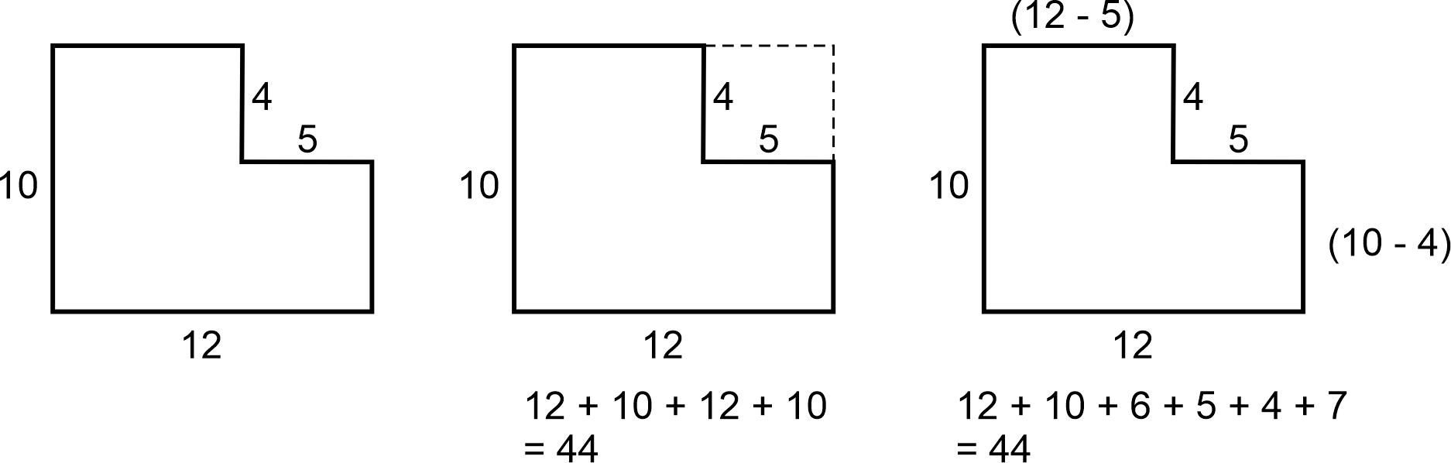
- Consider the two methods for find the perimeter of this shape:

Method 1: | Method 2:
  - For each method, describe what was done to work out the perimeter.

Method 1: We “pushed” the inside edges out, creating a rectangle.
Method 2: We found the missing sides by subtraction.
  - Which method do you think is more efficient?
First method
- Calculate the perimeter, using the method you prefer.
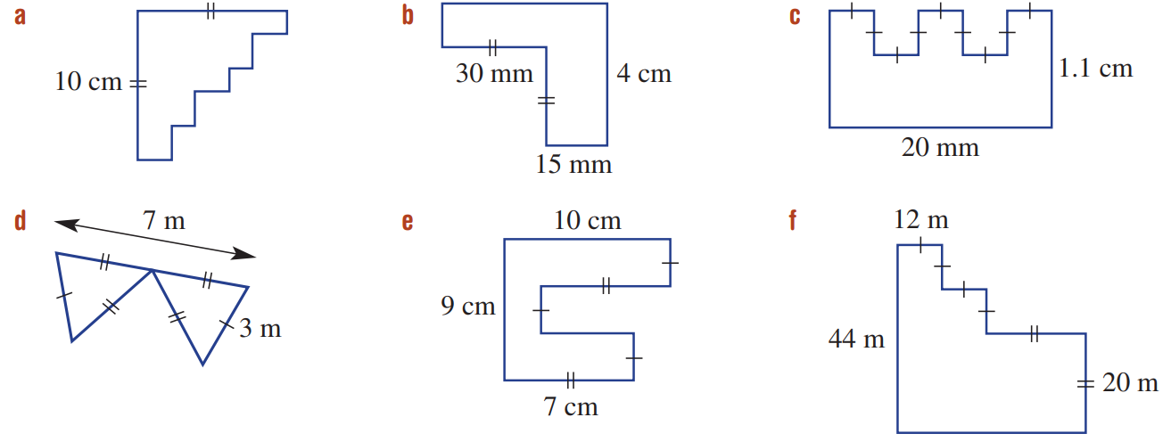  40 cm | 17 cm | 78 cm
20 m | 46 cm | 176 m

- Find the value of $x$
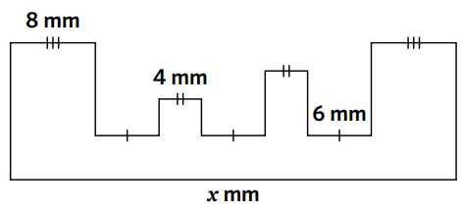  42 mm | 12 mm | 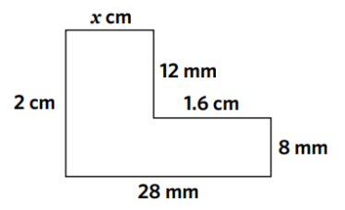  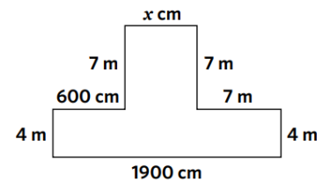  600 cm

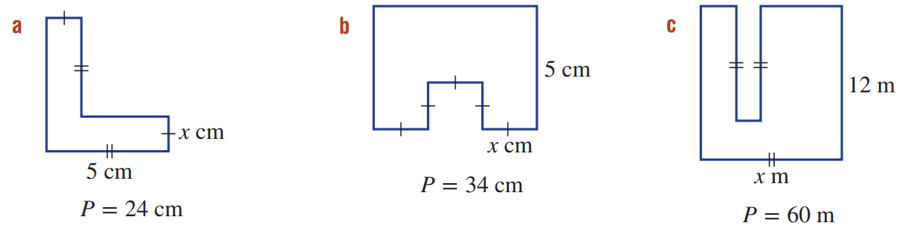
- Find the unknown value $x$, given the perimeter.
- $P=24$cm  2 cm | - $P=34$ cm  3 cm | - $P=60$ m  9 m

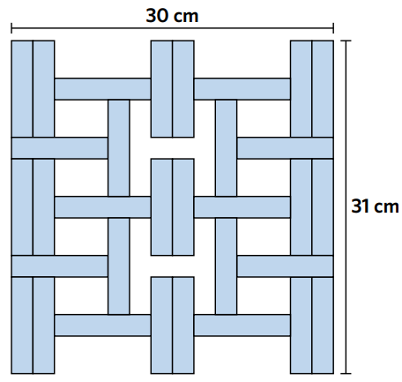
- Determine the length and width of each of the small identical rectangles.

$$6x+2y=30$$
$$2x+3y=31$$
By guess and check:
$$y=9$$
$$x=2$$

Solving Perimeter Problems

- Review
- Find the unknown number to make these equations true
- $38=29+$ ……… | - $89+$ ……… $=98$ | - $64=12+6+$ ………
- $9+$……… $=16$ | - $a+6+85=95$ | - $10+d=36.8$

- Solve these equations, showing inverse operations.
- $13+x=28$  $-13 -13$  $x=$ …… | - $x+27=45$  …… ……  $x=$ …… | - $8+x=30$  …… ……  $x=$ …… | - $x+13=73$  …… ……  $x=$ ……
- $22+x=28$ | - $x+17=60$ | - $160+x=300$ | - $x+135=170$

- Solve these equations. Simplify the equation first.
- $13+4+x=28$  $$17+x=28$$  $x=$ …… | - $x+12+3=21$  $x+$ …… $=21$  $x=$ …… | - $x+x=32$  …$x=32$  $x=$ ……
- $x+13+12=37$ | - $x+x+x=45$ | - $x+x+3+7=36$

- Solving Perimeter Problems
To find an unknown side length, given the perimeter:
- Write the equation.
- Substitute given information.
- Simplify by combining like terms.
- Solve for the unknown.

- Example Calculate side length, given perimeter
Calculate the missing length of this triangle if the perimeter is 75 mm.

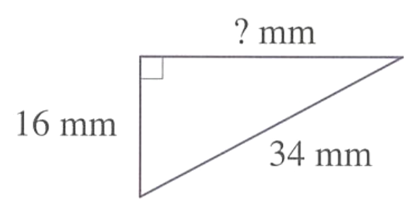
1. $P=16+34+x$
$$x$$
2. $75=16+34+x$
3. $75=50+x$
4. $25=x$

- Guided Practice
- $P=12$ cm
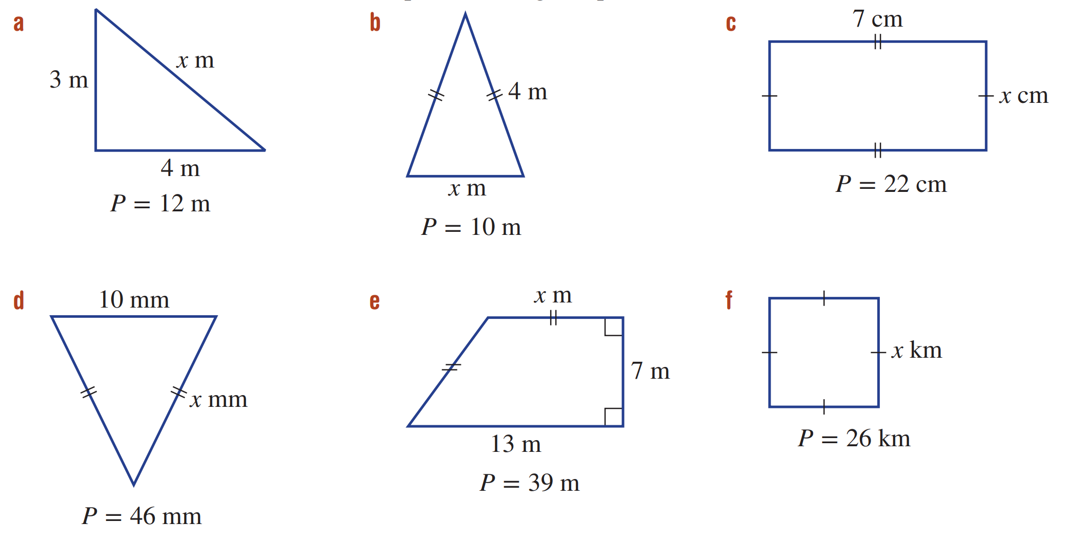
$P=3+4+x$
…… $=3+4+x$
…… $=$ …… $+x$
…… $=x$

$x=5$ cm
- $P=10$ cm

$x=2$ m
- $P=22$ m

$x=4$ cm

Foundation
- All of these shapes have perimeter 50 cm. Find the lengths of the missing sides.
All lengths are given in centimetres.
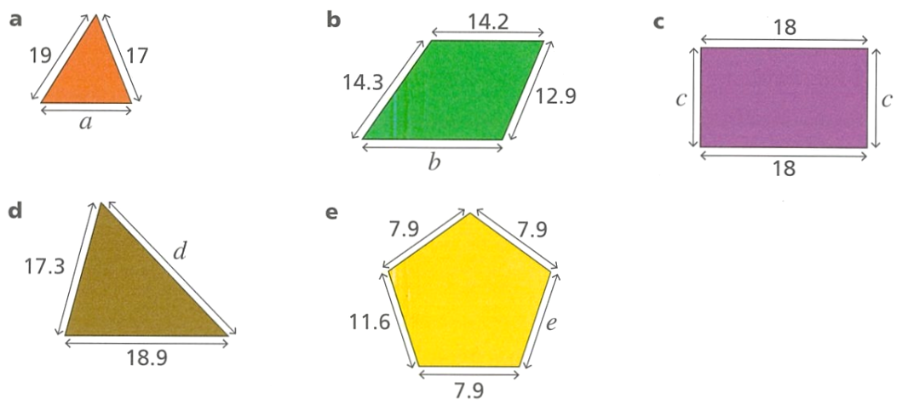  $P=19+17+a$  $50=36+a$  ……… $=a$  14 cm | 8.6 cm | 7 cm
13.8 cm | 14.7 cm | - Find the side length of a square with perimeter  50 cm.  12.5 cm

- Find the missing length in these shapes. The perimeter is given.
- $P=46 mm$  18 mm | - $P=39 m$  9.5 m | - $P=26 km$  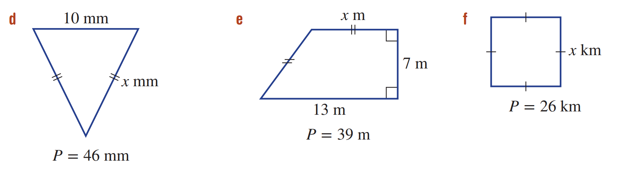  6.5 cm

- The length of a rectangle is 6.7 cm. Its perimeter is 22.6 cm. Find the width of the rectangle.
(Hint: Draw a diagram. Label the width $x$)

4.6 cm

Development
- A rectangle has a perimeter of 126 cm. Calculate the breadth if the length is 0.3 m.

33 cm
- A rectangular garden bed is twice as long as it is wide.
Calculate the length and width if the perimeter is 72 cm.

12 cm
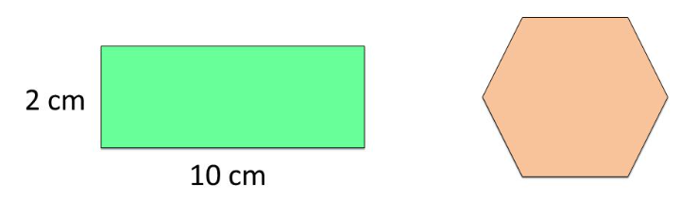
- The perimeter of the two shapes are equal. Work out the side length of the regular hexagon.

4 cm
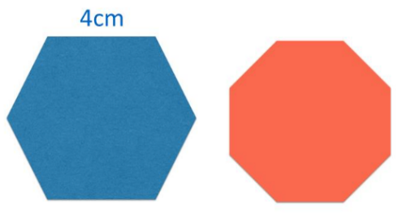
- The perimeter of the two shapes is equal. Work out the side length of the regular octagon.

3 cm
- Aragorn is fencing a paddock on his property. The total length of fencing he requires is 8.2 kilometres. The length of the paddock is 2.8 kilometres. How wide is the paddock? Answer in kilometres rounded to 1 decimal place.
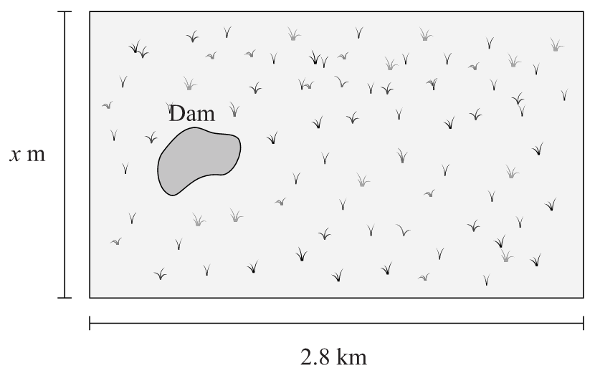

1.3 km
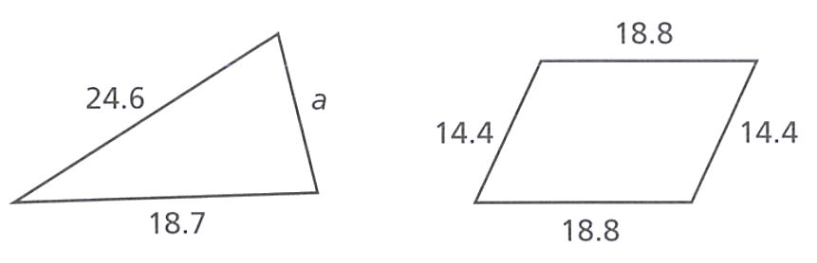
- These two shapes have the same perimeter. What is the length of the missing side?
All measurements are in cm.

23.1 cm
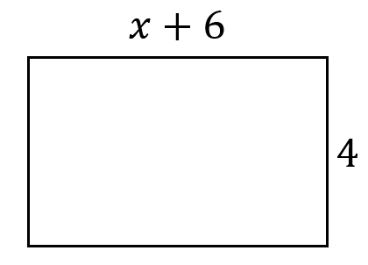
- Find the value of $x$ if the perimeter is 30 cm.

5 cm

Features of Circles

- Identify Features of circles
Feature | Definition | Example(s)
Circumference | The circumference of a circle is the perimeter, or distance around the outside of a circle.
Arc | An arc is a part of the circumference.
Centre | All points on the circumference is the same distance from the centre.  The real definition of a circle is: a shape made by connecting all points an equal distance from the centre.
Tangent | A tangent is a straight line that touches the circumference at a single point without entering the circle.
Chord | A chord is a straight line that goes from one point on the circumference to another point
Diameter | The diameter is a special chord that goes through the centre of the circle.
Radius | The radius is a line connecting the centre of a circle to the circumference. It is half the diameter.
Segment | A segment is the area between a chord and the circumference.
Sector | A sector is the area between two radii. | Quadrant: semicircle

- Summary of Circle Features
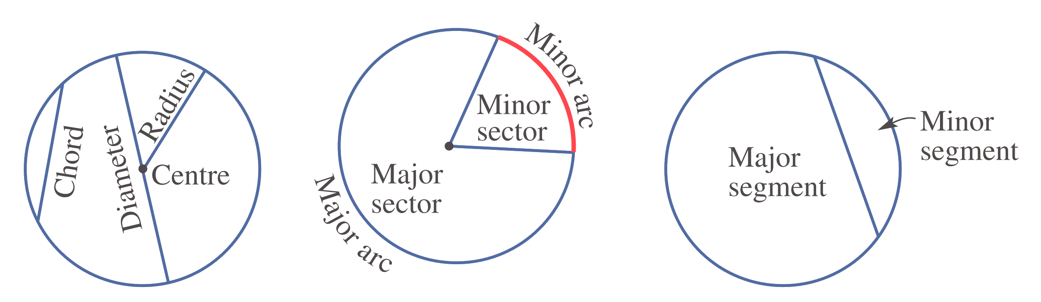

- Circumference Radius Diameter
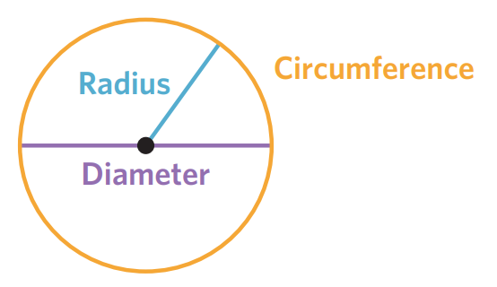

- Circumference is a circle’s perimeter.
- A radius is a straight line from the centre to the circumference.
- A diameter is a straight line through the centre, connecting two points on the circumference.
- The radius is half the diameter; the diameter is double the radius.

- Distinguish between radius and diameter
For each circle, identify whether the straight lines show the radius, diameter, or neither.
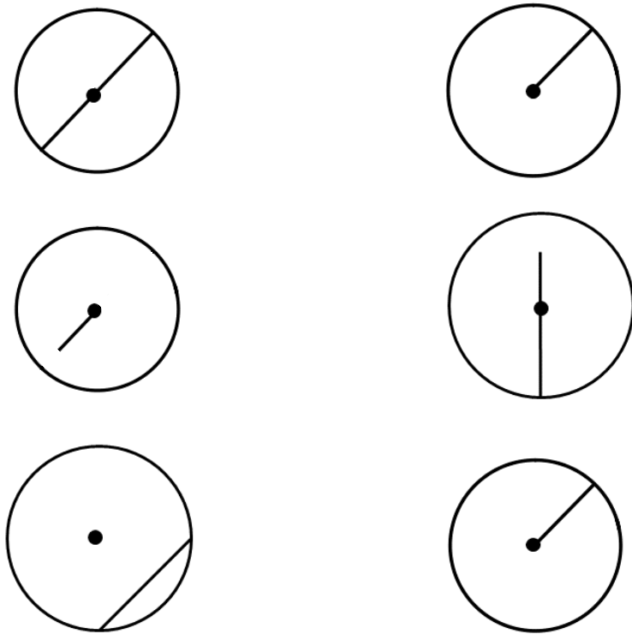  Radius  Diameter  Neither | Radius  Diameter  Neither
Radius  Diameter  Neither | Radius  Diameter  Neither
Radius  Diameter  Neither | 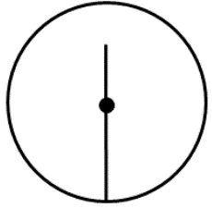  Radius  Diameter  Neither
Radius  Diameter  Neither | Radius  Diameter  Neither

Foundation
- Complete the sentences.
  - The circumference is the ……………… of a circle.
perimeter
  - The radius is a straight line connecting the ……………………… to the ……………………
Centre, circumference
  - The diameter is a straight line connecting two points on the ………………………, passing
through the ……………………
circumference, centre
  - The diameter is ………………… the length of the radius.
double
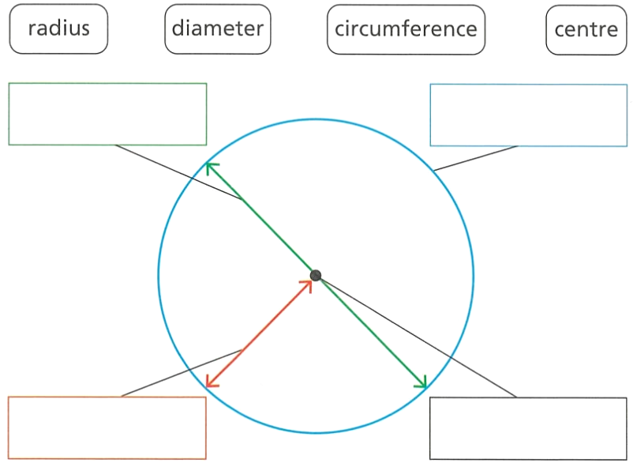
- Label these parts of the circle.

From top left: diameter, circumference, centre, radius

- Circle which of these (a, b, or c) show a radius.
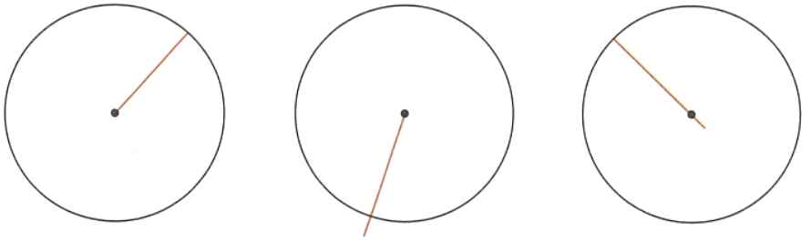

A
- Circle which of these (a, b, or c) show a diameter.
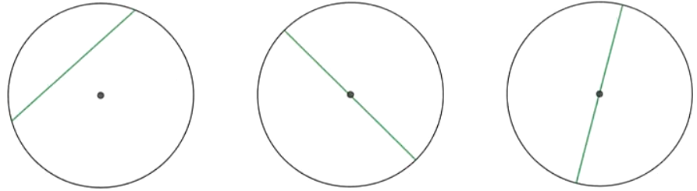

B

- Complete the table.
Radius | Diameter
4 cm | 8 cm
50 mm | 100 mm
12.5 cm | 25 cm
3.4 cm | 6.8 cm
$$\frac{3}{4} cm$$ | $$\frac{6}{4}=\frac{3}{2} cm$$

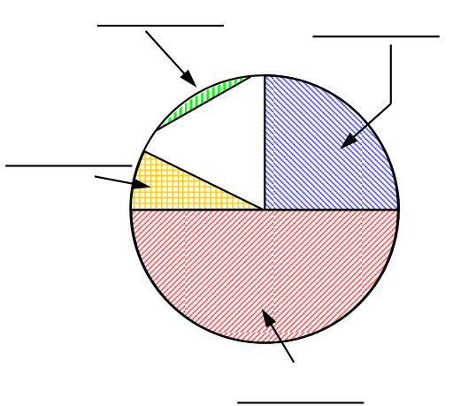
- Name the parts of the circle, then complete the sentences.
Answer to diagram, from top left: segment, quadrant, semicircle, sector
  - Pizzas are usually sliced into ………………………
sectors
  - A …………………… has a 90-degree angle.
quadrant
  - Two ……………………… make a semicircle.
quadrants
  - An arc and two radii make a ………………………
sector
  - The …………………… is a line through the circle that may not touch the centre.
chord
  - The area between a chord and the circumference is called the ……………………
segment
  - A ……………………… has the circle’s diameter as one of the sides.
Semicircle

- Name the highlighted parts of the circle.
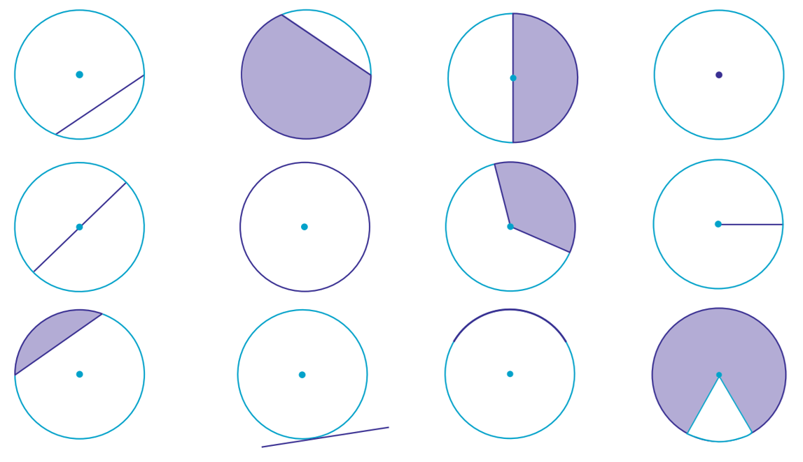  chord | segment | semicircle | centre
diameter | circumference | sector | radius
segment | tangent | arc | sector

Circumference of a Circle

- Review
- Round these numbers as indicated.

Number | Nearest whole | One decimal place | Two decimal places
31.2
31.27
31.472
31.4128
31.953
31.992

- Simplify these expressions.
- $2×x$ | - $2×4×x$ | - $2×8×y$ | - $2×3x$
- $3×π$ | - $4×3×π$ | - $3×5×π$ | - $8×5π$

- Investigation Pi $π$
- Pi: https://www.geogebra.org/m/jvhknzkw

In this investigation we will ‘unroll’ a circle and compare the circumference to the diameter.

Circumference | Diameter | $$\frac{Circumference}{Diameter}$$
 | 2
 | 3
 | 6
 | 10

For any circle, circumference ………………… ……… diameter is always 3.14159…
This means that the diameter of any circle will fit around the ………………… just over 3 times.
We represent this special number using the pronumeral $π,$and call it “………”
- Pi as a ratio: https://www.geogebra.org/m/wtxutssn
Since we have the relationship $\frac{C}{d}$ $=π$, we can rearrange this relationship to find $C:$

- Circumference: Diameter Formula
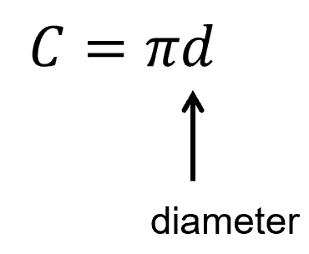
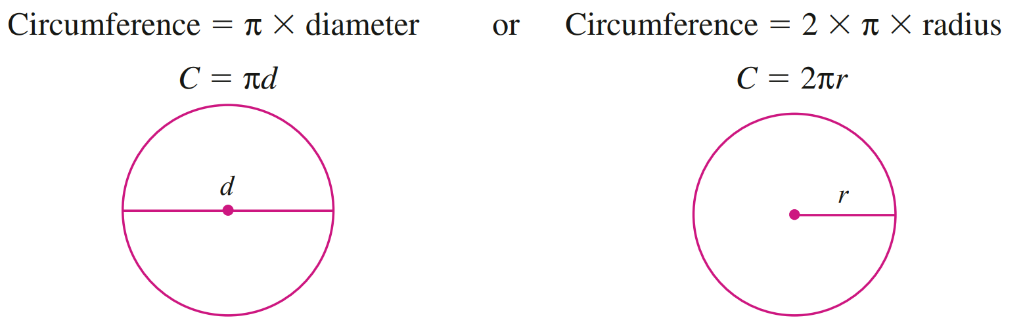

- Example Calculate circumference of a circle using diameter
Calculate the circumference of this circle, round your answer to 3 decimal places.
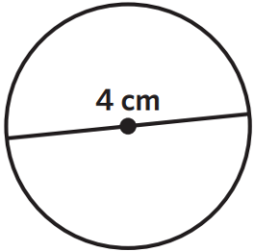
$C=πd$
$=π×4$
$≈12.566$ cm

- Guided Practice
Calculate the circumference of these circles to 3 decimal places.
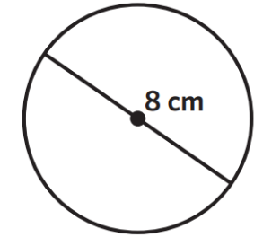
$C=πd$
$=$ $π$ $×$ ………
$≈$ ………………

25.133 cm
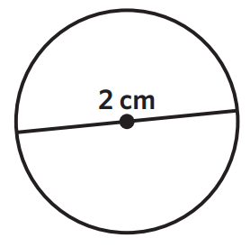

6.283 cm
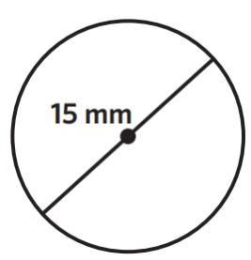

47.124 mm

- Circumference: Radius Formula
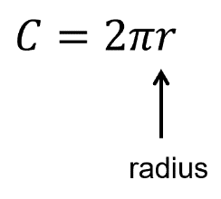

- Example Calculate circumference of a circle using radius
Calculate the circumference of this circle, round your answer to 3 decimal places.
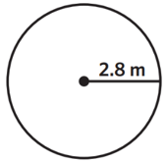
$C=2πr$
$=2×π×2.8$
$≈17.593$ m

- Guided Practice
Calculate the circumference of these circles to 3 decimal places.
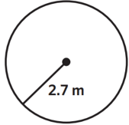
$C=2πr$
$=$ $2π×$ ………
$≈$ ………………

25.133 cm
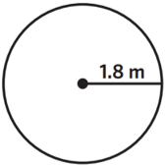

6.283 cm
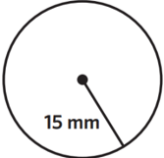

47.124 mm

Foundation
- Identify the radius and diameter of these circles.
Radius: ……………  6 m  Diameter: ……………  12 m | Radius: ……………  24 mm  Diameter: ……………  48 mm | 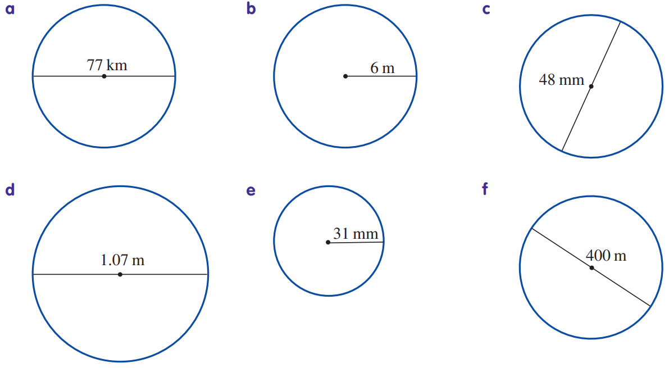  Radius: ……………  38.5 km  Diameter: ……………  77 km

- Use these diagrams to find approximate values for $π$
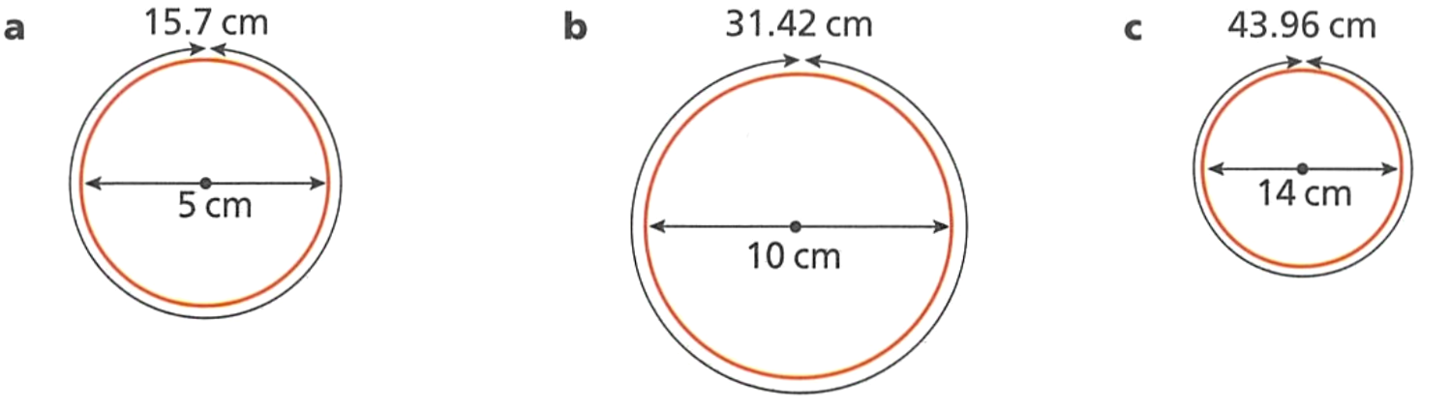  $$π=\frac{C}{d}$$  $=$ ………………  $=$ ………………  3.14 | $$π=\frac{C}{d}$$  $=$ ………………  $=$ ………………  3.14 | $$π=\frac{C}{d}$$  $=$ ………………  $=$ ………………  3.14

- Calculate the circumference of these circles using a calculator. Choose the correct formula and follow the setting out. Round answers to 2 decimal places.
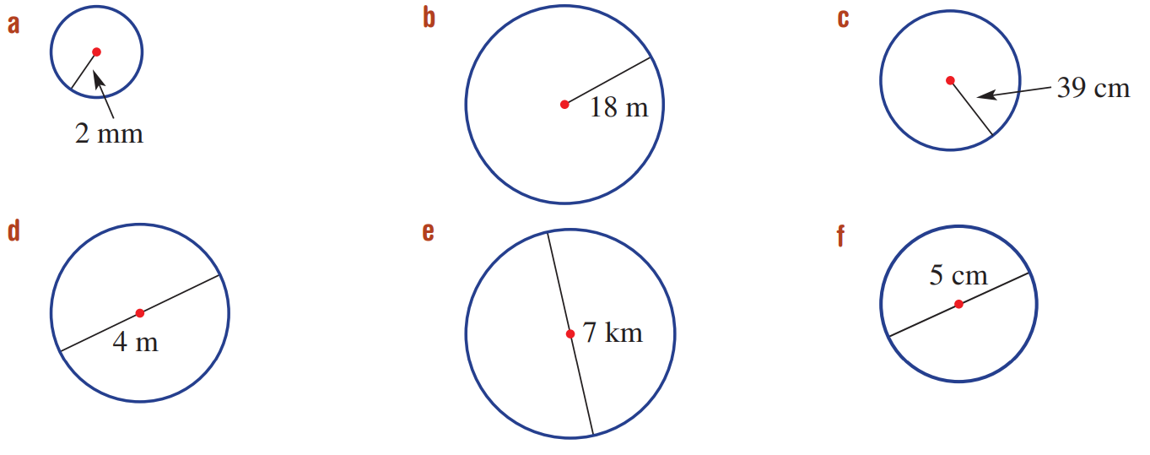  $C=2πr$  $=$ ………………  $=$ ………………  12.57 mm | $C=2πr$  $=$ ………………  $=$ ………………  113.10 m | $C=πd$  $=$ ………………  $=$ ………………  21.99 km
$C=$ ………………  $=$ ………………  $=$ ………………  12.57 m | $C=$ ………………  $=$ ………………  $=$ ………………  245.04 km | $C=$ ………………  $=$ ………………  $=$ ………………  15.71 cm

Development
- Calculate the circumferences of these two circles and show that they are the same circle. Explain why.
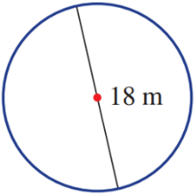
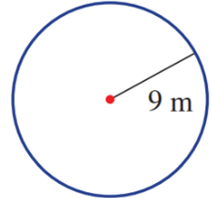

Circle 1: $C=18π$
Circle 2: $C=18π$
A radius of 9 m is the same as a diameter of 18 cm
- Carefully look at this working out. Explain why it is incorrect.
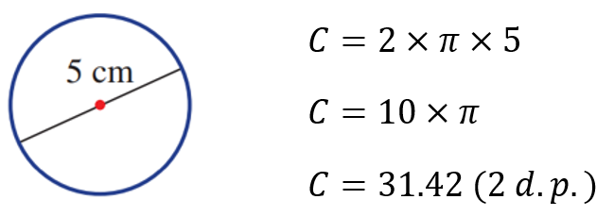
✖

They used $C=2πr$ and incorrectly used 5 as the radius. The radius should be 2.5 cm

- A water tank has a diameter of 3.5 m. Find its circumference, correct to 1 decimal place.

11.0 m
- An athlete trains on a circular track of radius 40 m and jogs 10 laps each day, 5 days a week. How far does he jog each week? Round the answer to the nearest whole number of metres.

125 66 m
- Which sushi roll has the larger circumference?
One with a radius 20 mm or one with a diameter 4.5 cm? Justify your answer.

20 cm radius: $C=125.66$ mm
4.5 cm diameter: $C=141.37$ mm
The sushi with 4.5 cm diameter has larger circumference.
- It is more precise to give circle calculations in terms of $π$. $C=2×π×3$ gives $C = 6π$.
This gives the exact answer and not a rounded decimal.
Calculate the circumferences of these circles, giving exact answers in terms of $π$.
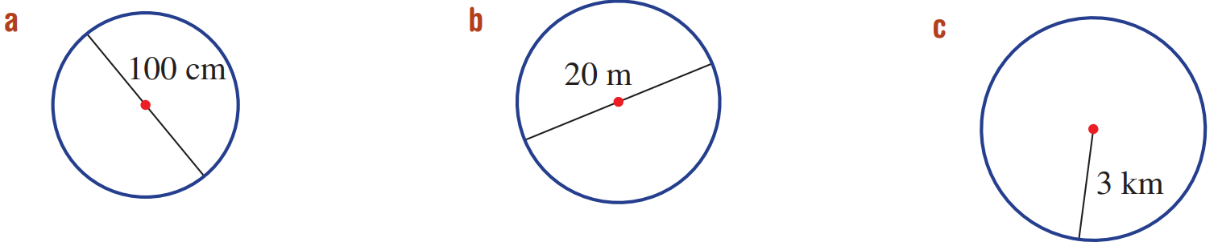  100$π$ cm | 20$π$ m | 6$π$ km
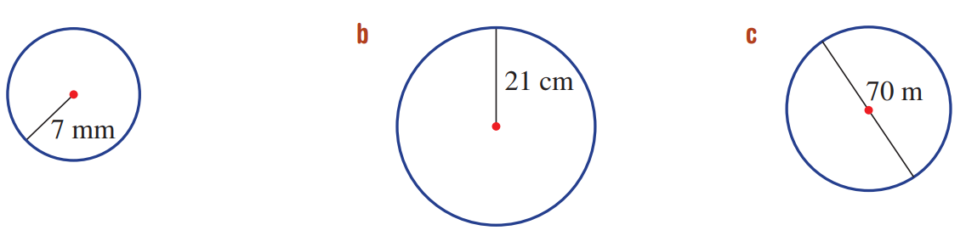  14$π$ mm | 42$π$ cm | 70$π$ m

- NAPLAN A+
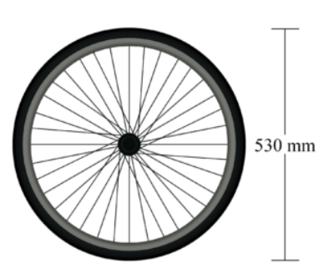
A wheel on a bicycle has a diameter of 530 mm. The wheel turns 3 times.
Approximately how many metres has the bicycle travelled?

5 m
- Faith goes on a 12 km bike ride. The wheels of her bike each have diameter 55 cm.
How many revolutions do her wheels make in the journey?

1 revolution is 55$π$ cm
$12000÷55π=$ 6945 revolutions

mastery
- In a Physics experiment, students spin a mass around on the end of a thread.
The thread is 80 cm in length. The mass is 5 kg.
Calculate the distance the weight travels if it spins a total of 4230°.
Give your answer in metres rounded to two decimal places.
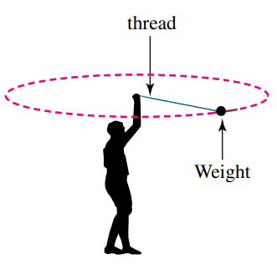

$4230÷360=11.75$ revolutions
$11.75×2π\left(0.8\right)=$ 59.06 m
- Darling Harbour is planning to install a new Ferris wheel. The wheel has a diameter of 80 m. The pods can carry 10 passengers each but need to be spaced out by at least 10 m around the circumference of the Ferris wheel.
What is the maximum number of passengers that can be on the Ferris wheel at one time?

$C=80π$ m
Number of pods = $80π÷10≈25$
Number of people $=25×10=250$ people
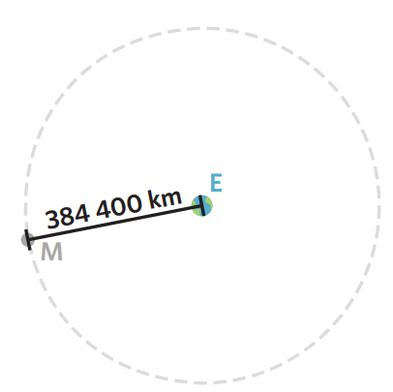
- An object in space orbits another object on a path that is very close to a circle.
Answer these questions rounded to the nearest whole number.
  - The Moon is approximately 384,400 km from the Earth. Calculate the distance the Moon travels in one orbit of Earth.
Round to the nearest whole.

$C=2π\left(384400\right)≈2 415 256$km
  - The Moon takes 27.32 days to orbit the Earth.
Calculate how many kilometres it travels per hour.
Round to the nearest whole.

$$\frac{2415256 km}{27.32 days}=88406.16 km/day$$
$88406.16÷24≈3684$ km/h
  - The Earth is approximately 150 million km from the Sun. It orbits the Sun in 365.25 days. Calculate how many kilometres it travels around the Sun each hour.
Round to the nearest whole.

$$\frac{2π\left(150 000 000\right) km}{365.25×24 hours}=107 515 km/h$$

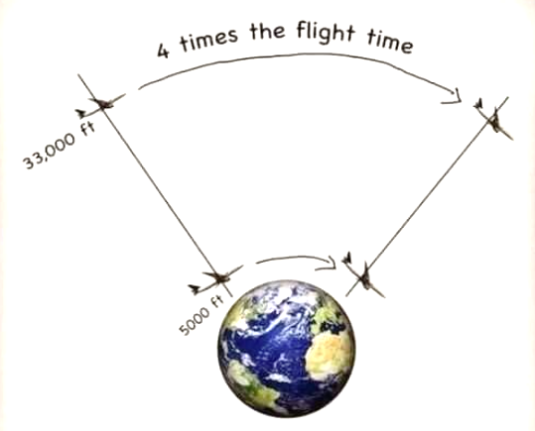
- Mr Ding is scrolling Instagram and comes across this post:

“If the Earth were round, then planes wouldn’t fly so far up, as they would waste lots of fuel and money. This proves that the earth must be flat!”

Using mathematical reasoning, justify whether this post is factually correct.
The radius of the Earth is around 21 000 000 feet. Planes usually do fly at 33 000 feet.

Consider a plane flying around the Earth.
At 5000 feet, $C=2π\left(21 005 000\right)=42 010 000π$
At 33000 feet: $C=2π\left(21 033 000\right)=42 066 000π$
Comparing the two: $\frac{42 066 000π}{42 010 000π}=1.001333016…$
The increase in distance is only 0.13%, so the flight would not take 4 times as long.
The diagram is misleading, as the Earth is not drawn to the correct scale (planes don’t fly in space).

Arc Length of a Circle

- Review
- Write the fraction of the whole circle. All angles show the internal angle.
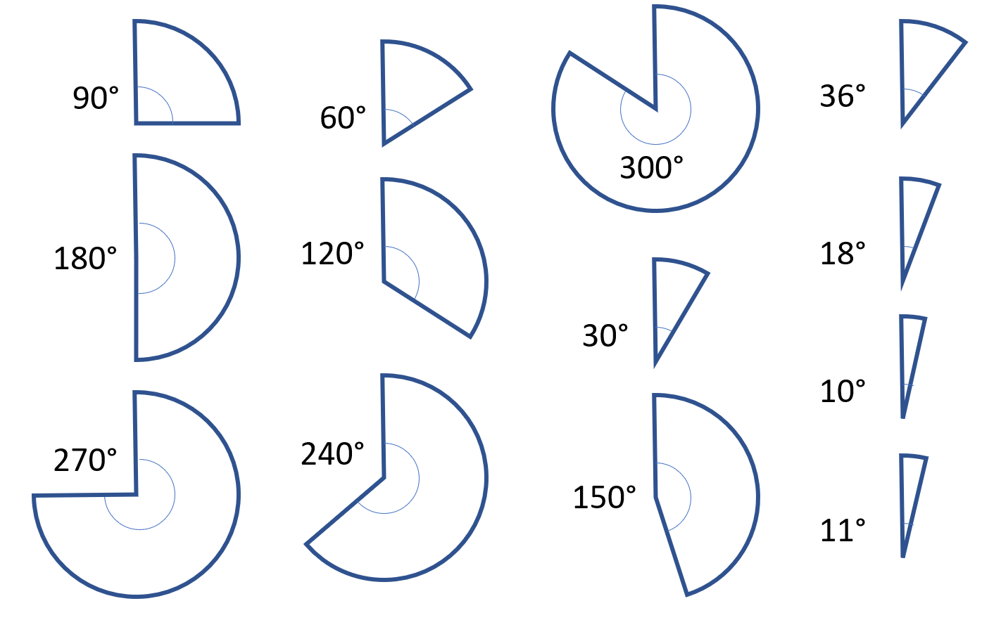

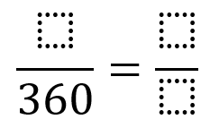

- Find fraction of a quantity. Answer to 2 d.p. where necessary.
- $\frac{1}{2}$ of 30  $$\frac{1}{2}×30=$$ | - $\frac{2}{5}$ of 72 | - $\frac{1}{4}$ of $3π$

- Arcs
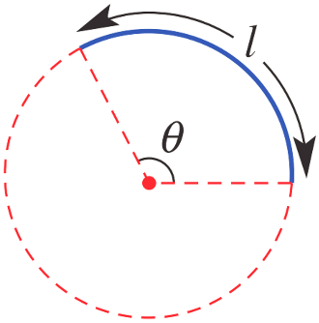
- An arc is a part of the circumference.
- Arcs subtend, or form, an angle at the centre of an imaginary circle.
We call this angle $θ$.

- Arc Length of a Circle
Angle | Diagram | Fraction of  a whole circle | Arc length
$$360°$$ | 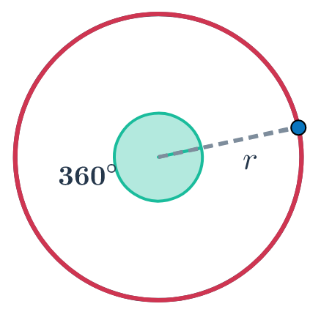 | $$\frac{360°}{360°}=1$$ | $$l=2πr$$
$$180°$$ | 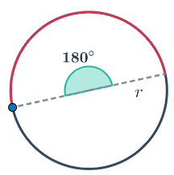 | $$\frac{180°}{360°}=$$ | $$l=\frac{}{ }×2πr$$
$$90°$$ | 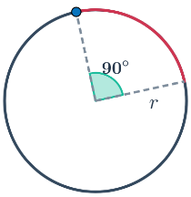
$$270°$$ | 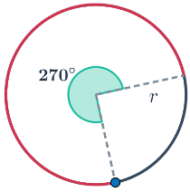
$$60°$$ | 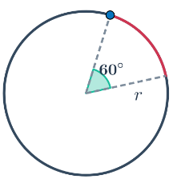
The arc length is a ……………… of the circumference. First we find the ……………… of the circumference that the arc length represents by looking at the angle …………………… at the centre, then ………………… the fraction by the circumference.

- Arc Length
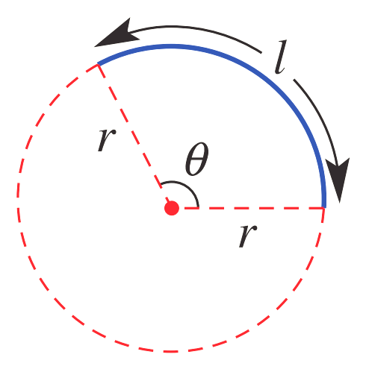
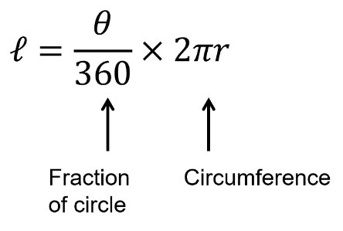

- Example Success Criteria
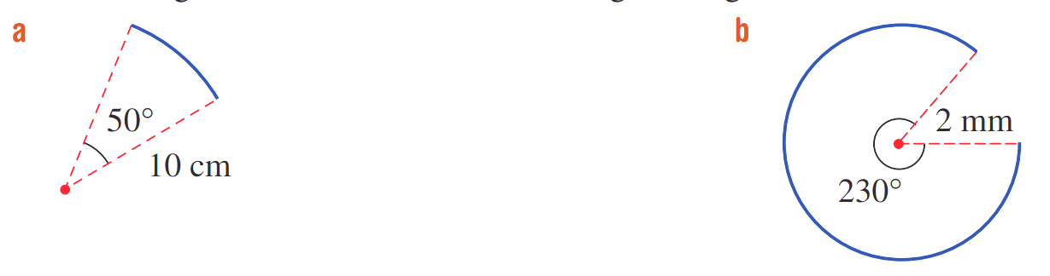
Calculate the arc length. Round your answer to 2 decimal places.
$$l=\frac{θ}{360}×2πr$$

$$=\frac{50}{360}×2π\left(10\right)$$

$=8.73$cm

- Guided Practice
Calculate the arc length. Round your answer to 2 decimal places.
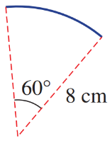
$$l=\frac{θ}{360}×2πr$$
$=$ $\frac{}{360}$ $×2π\left(8\right)$
$=$ …………………
8.38 cm

8.03 mm
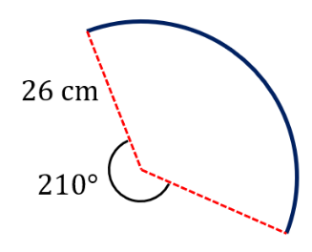

68.07 cm

Foundation
- Calculate these arc lengths. Round your answer to 2 decimal places.
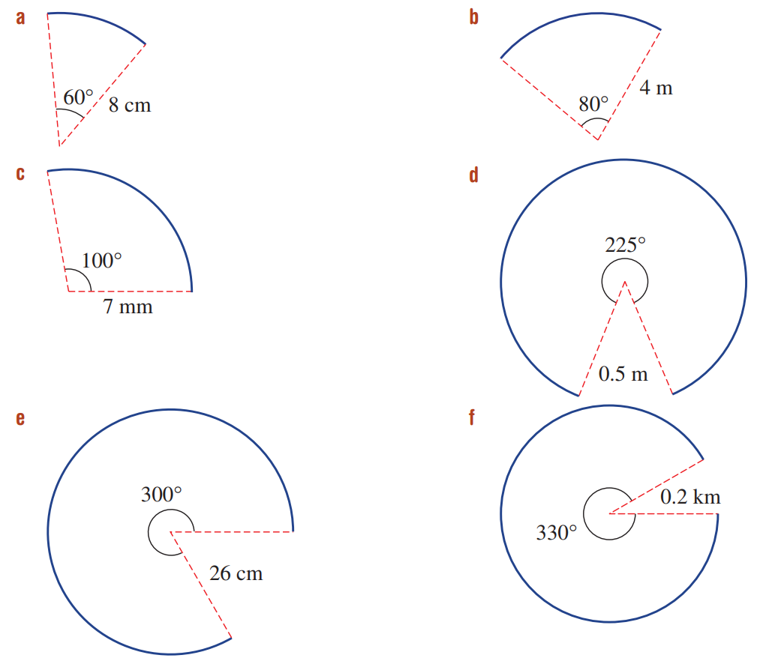  $$l=\frac{θ}{360}×2πr$$  $=$ …………………  $=$ …………………  5.59 m | $l=$ …………………  $=$ …………………  $=$ …………………  6.98 mm | $l=$ …………………  $=$ …………………  $=$ …………………  1.96 m | $l=$ …………………  $=$ …………………  $=$ …………………  1.15 km

- Calculate the length of these arcs. Give your answer in exact form by leaving it in terms of $π$.
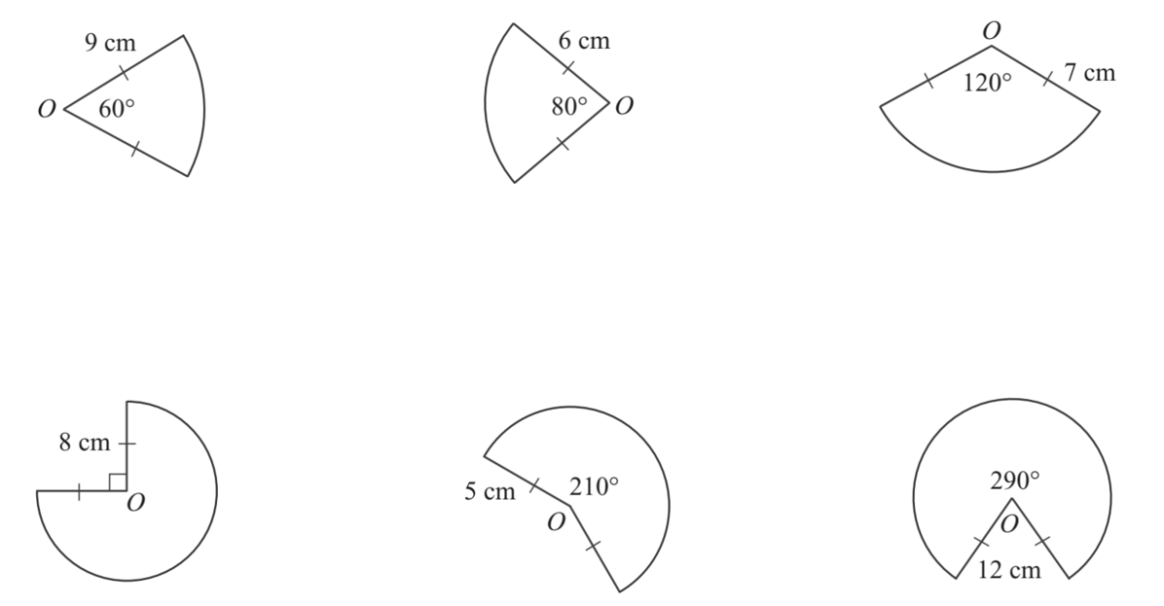  3$π$ cm | $$\frac{14}{3}π cm$$ | $$\frac{8}{3}π cm$$
$$12π cm$$ | $$\frac{35}{6}π cm$$ | $$\frac{58}{3}π cm$$

- Calculate the arc length. The angle shown is the exterior angle. Answer to 2 decimal places.
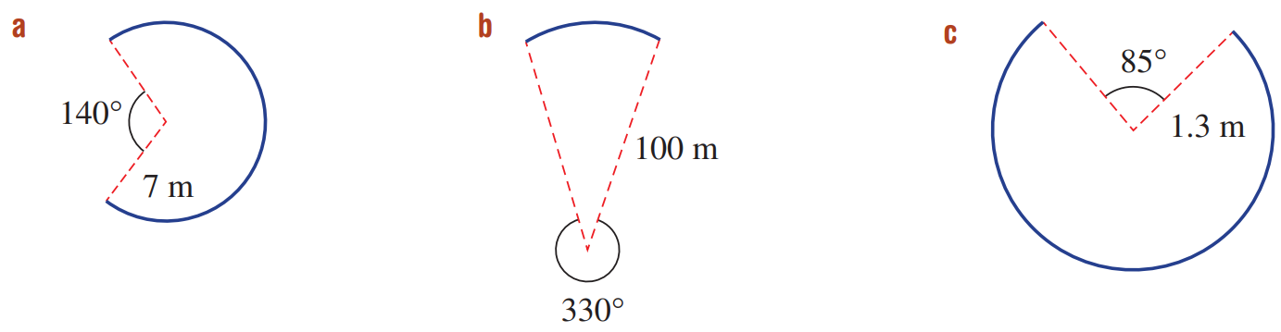  26.88 m | 52.36 m | 6.24 m

Development
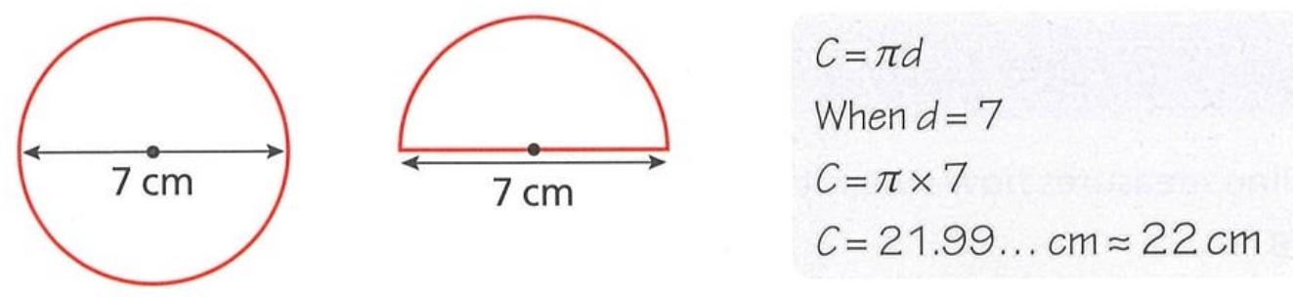
- Claire works out the circumference of the circle correctly:


The circumference of the circle is 22 cm,
so the semicircle perimeter is 22 cm $÷$ 2 = 11 cm

Explain why she is wrong and find the correct perimeter of the semicircle.

The perimeter includes the diameter, so it is 18 cm.
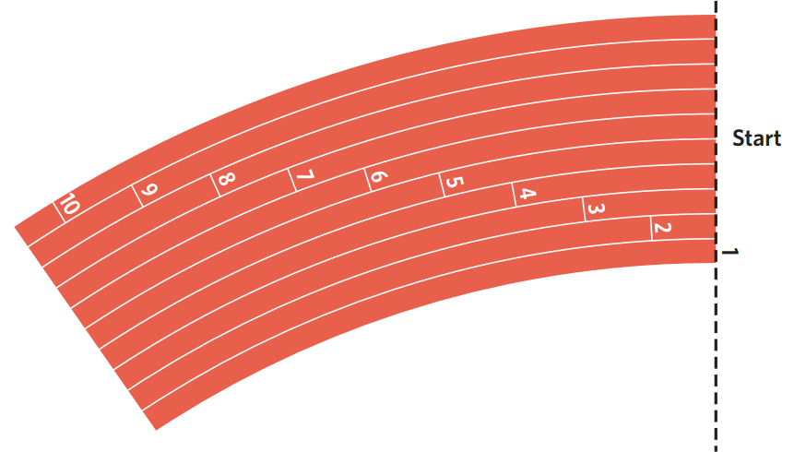
- One lap of an athletics track is 400 m.
One of the races at the Olympics is the 200 m, which is half the track.
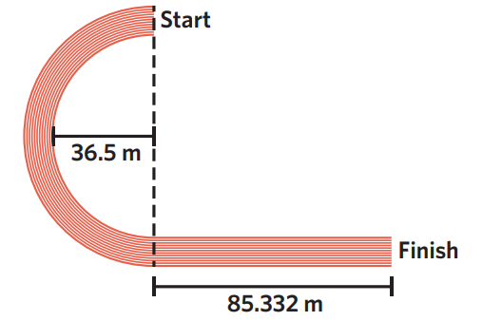

  - Show that the arc length of a semicircle with a radius of 36.5 m and a straight line of 85.332 m has a total length of 200 m, correct to 3 decimal places.

Arc + straight distance
$$=\frac{1}{2}\left(2π\right)\left(36.5\right)+85.332$$
$=200$m
  - If each lane is one metre wide, that means the second lane is a semicircle with a radius of 37.5 m and a straight line of 85.332 m. Calculate the distance of the second lane.

$$=\frac{1}{2}\left(2π\right)\left(37.5\right)+85.332=203.14 m$$

  - Hence explain why the start of the lanes are slightly offset
(i.e., they don’t all start at the same place).

If the athletes all start at the same place, the runners at the outer lanes will run further, therefore the lanes are offset.

Finding the Radius, Given the Circumference

- Finding the Radius
If you are given the circumference and asked to find the radius:
- Write the formula.
- Substitute given values.
- Solve for the unknown value using inverse operations.
Circumference |  | Arc Length
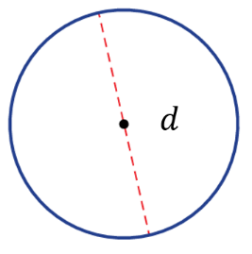  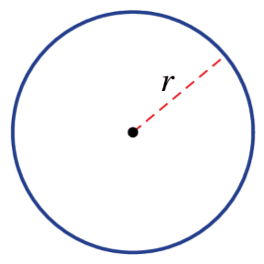  $C=πd$ | $$C=2πr$$ | $$l=\frac{θ}{360}×2πr$$  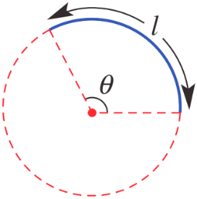

- Guided Practice
Worked Example | Your Turn
The circumference of a circle is 9 cm.  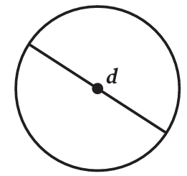  What is the diameter? Round to 3 d.p.  1. Write the formula $C=πd$  2. Substitute $9=πd$  3. Solve $÷π=÷π$$$\frac{9}{π}=d \\ 2.865≈d$$ | The circumference of a circle is 60 cm.  What is its diameter?  1.  2.  3.  19.099 cm
The circumference of a circle is 12.8 cm.  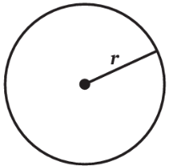  What is the radius? Round to 3 d.p.  1. Write the formula $C=2πr$  2. Substitute $12.8=2πr$  3. Solve $÷2π=÷2π$$$\frac{12.8}{2π}=r \\ 2.037≈r$$ | The circumference of a circle is 10.6 cm.  What is its radius?  1.  2.  3.  1.687 cm

Foundation
- Calculate the diameter of these circles, given the circumference. Round to nearest whole.
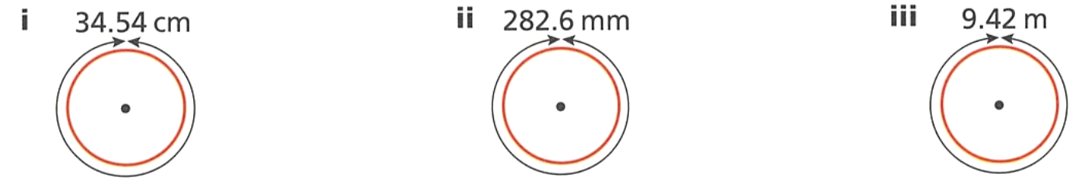  $$C=πd$$  11 cm | 90 cm | 3 cm

- Determine the values of the unknowns, correct to 3 decimal places.
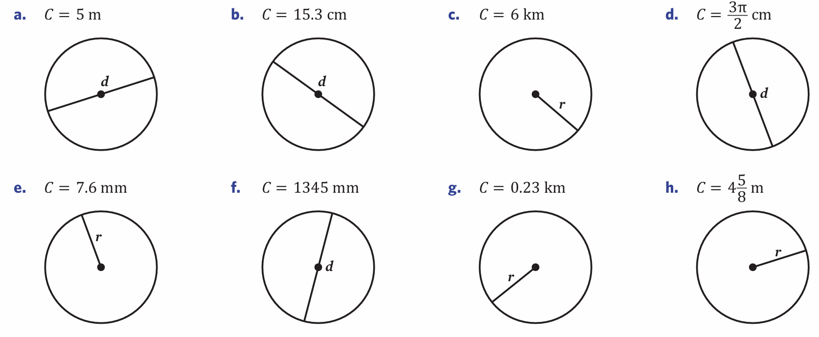  1.592 m | 4.870 cm | 0.955 km
1.210 mm | 0.037 km | $$\frac{3}{2} cm$$

- NAPLAN A
A car tyre has a circumference of 120 cm. Which of these is closest to the radius of the tyre?
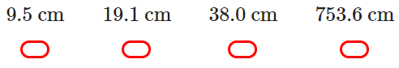

$$120=2πr$$
$$r=\frac{120}{2π}=19.09859…$$
B

Development
- The Earth is approximately a perfect circle at the equator.
The distance around the equator is 40 075 km.
Estimate the distance from the surface of the Earth to the centre, answer to the nearest km.

$$40075=2πr$$
$$r=\frac{40075}{2π}≈6378 km$$
- Flo uses a tape measure to find the circumference of a tree trunk.
She finds the circumference is 150 cm. She divided by 3 to estimate the diameter of the trunk.
  - Explain why she divided by 3.

$$π≈3$$
  - Would the actual diameter be more or less? Why?

$π≈3.14>3$. The actual diameter would be smaller, as dividing by a larger number gives a smaller result.
  - What should she divide by to estimate the radius?

Divide diameter by 2, or divide circumference by 6.
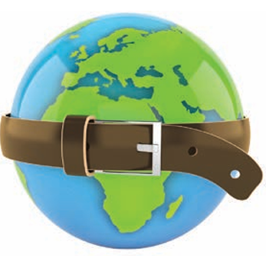
- Imagine that we wrapped a giant belt tightly around the Earth, along the Equator.
This belt would touch the Earth at all points on its circumference, assuming the Earth was a perfect sphere.
  - If the diameter of the Earth is 12 755 metres,
calculate to 2 decimal places, the length of the tight belt.

$C=π\left(12755\right)≈40071.01$ m
  - Now suppose we added one extra metre to the length of the belt.
Then it would become loose and not touch the Earth anymore.
Add 1 metre to the length of the tight belt. What is its length?

$C=40072.01$ m

  - Calculate the diameter of the longer, looser belt.

$$d=\frac{C}{π}=\frac{40072.01}{π}=12755.32 m$$
  - What is the gap between the Earth and the loose belt?
The gap is half the difference of the two diameters.
$$\left(12755.32-12755\right)÷2=0.16 m$$

Mastery
- Calculate the radius of these shapes, given the arc length. Answer to 2 d.p.
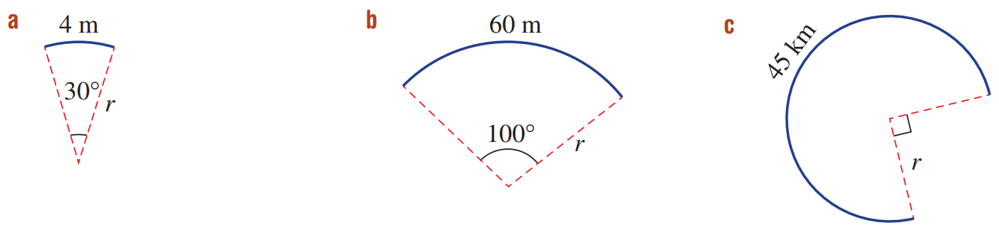  $$l=\frac{θ}{360}×2πr \\ 4=\frac{30}{360}×2πr$$  7.64 cm | 34.38 m | 9.55 km

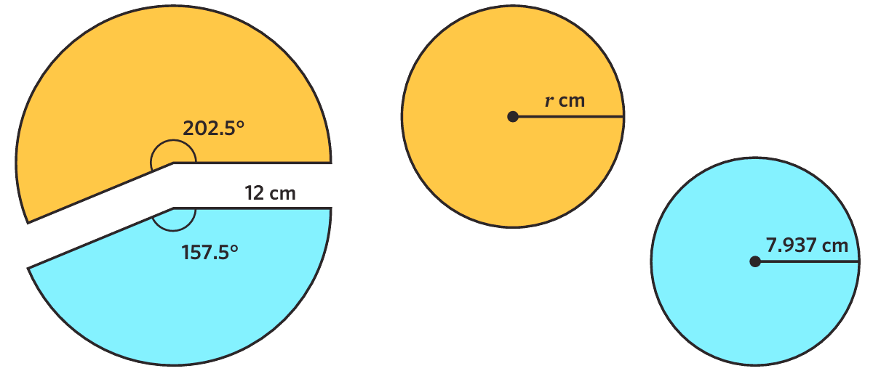
- Sean’s frisbee has a radius of 12 cm.
He cuts it into sectors of 202.5° and 157.5° and turns both into smaller frisbees.
What is the radius of the bigger of the two new frisbees? Answer to 2 d.p.

Let arc length of orange sector be $l$
$$l=\frac{202.5}{360}\left(2π\right)\left(12\right)=42.41150082…$$
This is the same as the circumference of the new frisbee
$$42.41150082=2πr$$
$r=6.75$ cm
- Suppose a belt tightly stretched around the equator of the earth just fits.
The diameter of Earth is 12 755 km.
  - How much longer should you make the belt so that the belt could encircle the earth at a distance of 1 m away at all points?

Tight belt length = $C=π\left(12755\right)≈40071.0143$ km
Loose belt length = $C=π\left(12756\right)=40077.2974$ km
Difference = $40077.2974-40071.043≈6.283≈2π$
  - Explain why the answer to “how much longer should you make a belt such that it encircles 1 m away from the original circumference” is always $2π$.

Original diameter: $d$
Original circumference: $πd$
New diameter: $d+2$
New circumference: $π\left(d+2\right)=πd+2π$
$∴$ new circumference is always exactly $2π$ more, doesn’t matter if it’s a balloon or the Earth.

Perimeter of a Sector

- Perimeter of a Sector
- A sector is the shape formed by two radii and the arc between them.
- The perimeter of a sector is the sum of the arc length and the two radii.
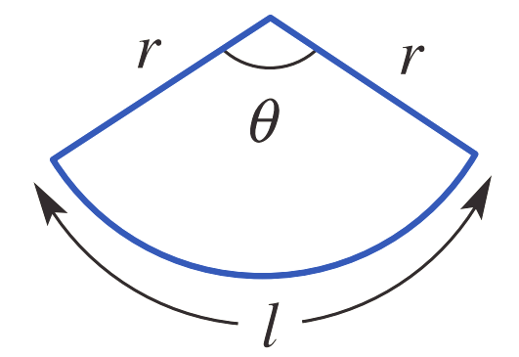

$P=l+2r$

- Example Calculate perimeter of a sector
Calculate the perimeter of the sector, round your answer to 1 decimal place.
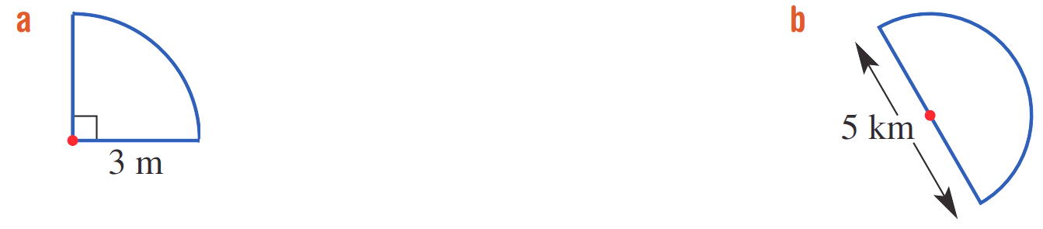
$P=l+2r$
$$=\left(\frac{90}{360}2π\left(3\right)\right)+\left(2\right)\left(3\right)$$
$=10.7$ m

- Guided Practice
Calculate the perimeter of these sectors to 1 decimal place.
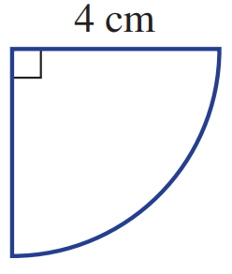
$P=l+2r$
$=$ $\frac{}{360}$ $2π\left( \right)+2( )$
$=$ ………………………

14.3 cm

12.9 km
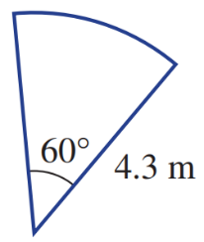

13.1 m

Foundation
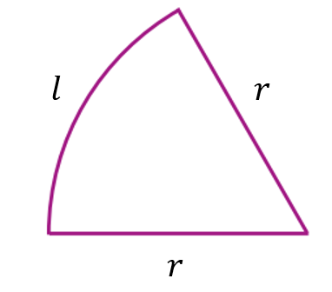
- Describe the difference between the arc length and the perimeter of a sector.
Refer to the diagram.

Arc length is just $l$
Perimeter is all sides on the outside of the shape $l+2r$
- Calculate the perimeter of these shapes. Answer to 2 d.p.
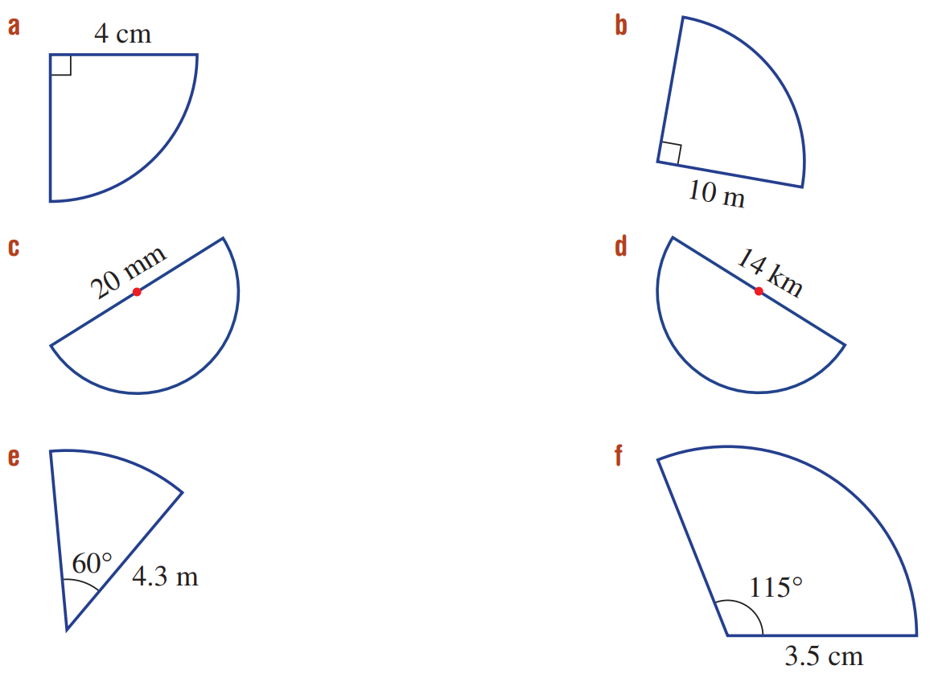  $P=l+2r$  $=$ $\frac{ }{360}$ $×2π\left( \right)+2( )$  $=$ ………………………  14.28 cm | 35.71 m | 51.42 mm
35.99 km | 13.1 m | 14.02 cm

- Calculate the perimeter of these shapes. Answer to 1 d.p.
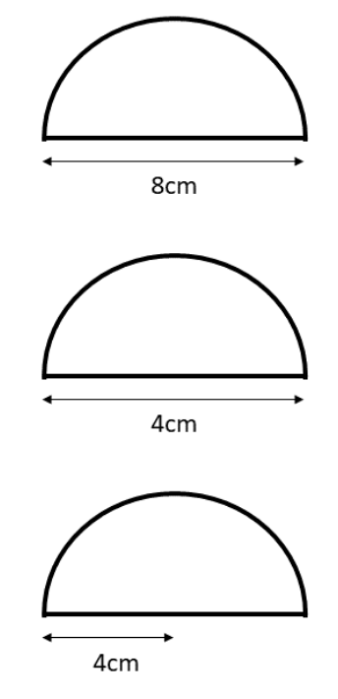  10.28 cm | 20.57 cm | 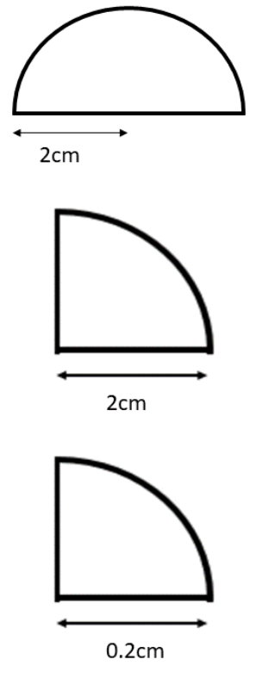  10.28 cm
7.14 cm | 0.71 cm | 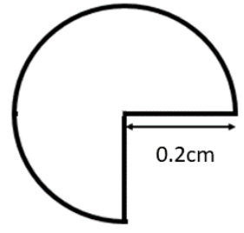  1.34 cm

Development
- 2019 HSC Standard 2 Band 4
The diagram shows a sector with an angle of 120° cut from a circle with radius 10 m.
What is the perimeter of the sector? Write your answer correct to 1 decimal place.
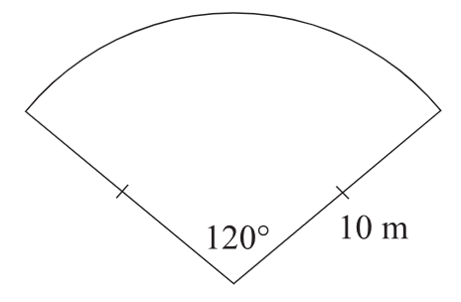

$$P=\frac{120}{360}×2π\left(10\right)+20$$
$$=40.94 m$$
- 2012 HSC Standard 2 Band 5
The sector shown has a radius of 13 cm and an angle of 230°.
What is the perimeter of the sector to the nearest centimetre?
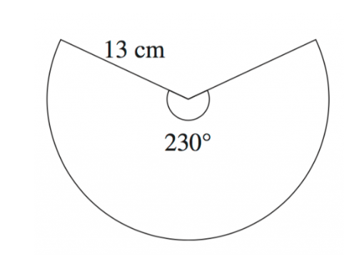

$$P=\frac{230}{360}×2π\left(13\right)+26$$
$=78.19$ cm
- NAPLAN A+
Peter cuts a sector from a circle so that three eighths of the area remains.
If the circle's radius is 5 cm, what is the perimeter of the shape, to the nearest centimetre?
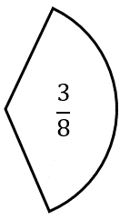

$$P=\frac{3}{8}×2π\left(5\right)+10=22 cm$$
- The perimeter of a sector is 40 cm.
If the radius of the sector is 10 cm, what is the angle at the centre? Answer to 1 d.p.
$$P=l+2r$$
$$40=\frac{θ}{360}×2π\left(10\right)+2\left(10\right)$$
$$40=\frac{π}{360}×20π+20$$
$$20=\frac{θ}{360}×20π$$
$$7200=20πθ$$
$$θ=\frac{7200}{20π}≈114.6°$$

- If the radius of a sector is 16 cm, is it possible to make a sector with perimeter 215 cm?
Justify your answer.

$$P = \left(\frac{θ}{360}\right)\left(2πr\right)+ 2r$$
$$215 = \left(\frac{θ}{360}\right)\left(2π\right)\left(16\right)+ 2\left(16\right)$$
$$215 = \left(\frac{θ}{360}\right)\left(32π\right)+ 32$$
$$183 =\frac{32πθ}{360}$$
$$θ =\frac{183 × 360}{32π}$$
$$θ ≈ 655.7°$$
No, it is not possible as a sector cannot have an angle of 655.7°

- The radii of a sector subtend an angle of $40°$ at the centre. Its perimeter is 10 cm.
What is the radius? Answer to 2 d.p.

$$P=l+2r$$
$$10=\frac{40}{360}×2πr+2r$$
$$10=\frac{2πr}{9}+2r$$
$$10=r\left(\frac{2π}{9}+2\right)$$
$$r=\frac{10}{\left(\frac{2π}{9}+2\right)}≈3.71 cm$$

Perimeter of Shapes involving Arc Length

- Review
- Calculate the perimeter of these sectors. Round to 1 d.p.
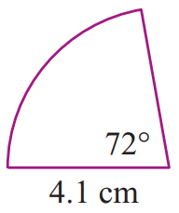  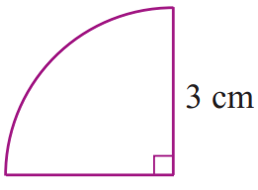 | 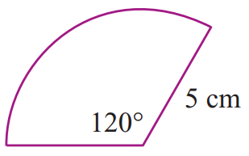  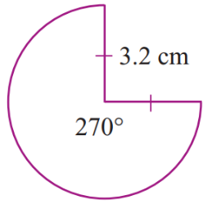

- Simplify the following, leaving your answer in exact form.
Do not round or use a calculator. Remember to follow the order of operations.
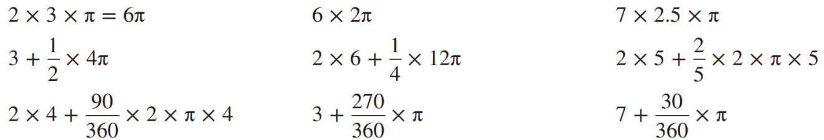
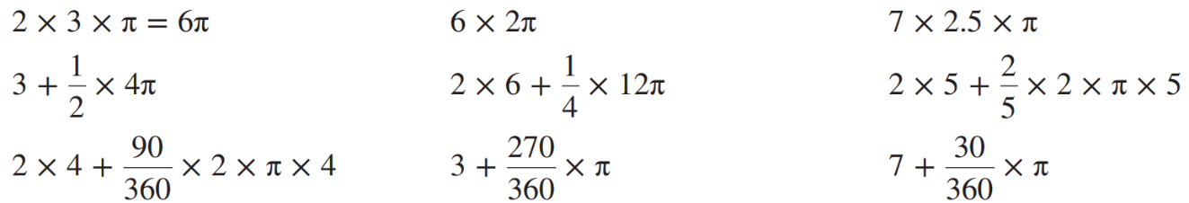

- Work out the perimeter of these shapes.
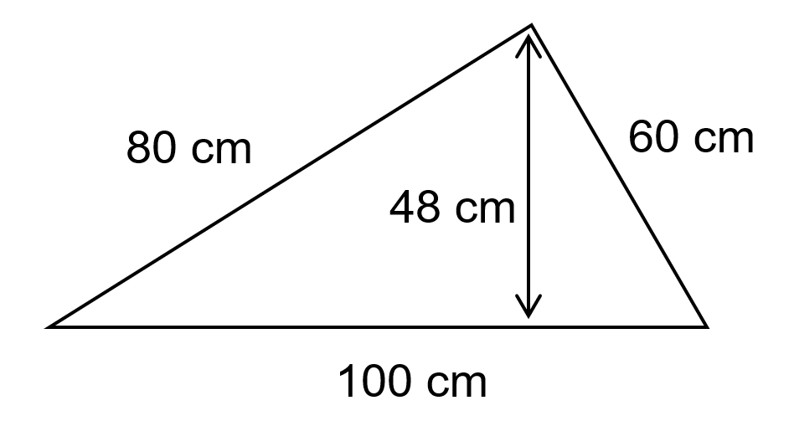 | 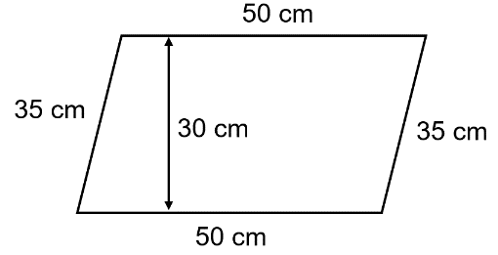

- Perimeter of Shapes involving Arc Length
To calculate the perimeter of a composite shape involving arc length:
- Label the diagram showing all lengths of the perimeter.
- Add the straight-line segments and the arc length.
- Calculate the answer.

- Example Calculate perimeter of a shape involving arc length
Calculate the perimeter of this shape, round your answer to 2 d.p.
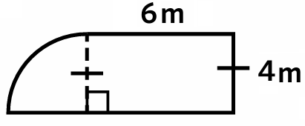  1.  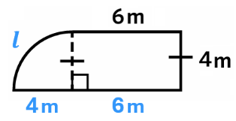 | $$2. P=6+4+6+4+l$$  $$3. P=20+\left(\frac{90}{360}×2π\left(4\right)\right)$$  $P=26.28$ m

- Guided Practice
Calculate the perimeter of these sectors to one decimal place.
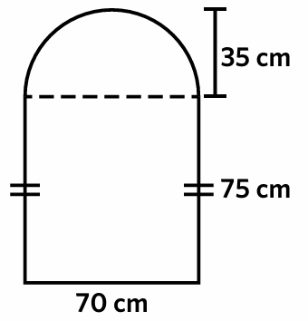

330.1 cm
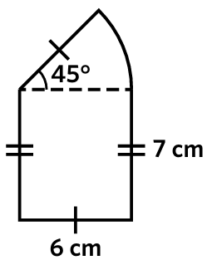

30.7 cm

Foundation
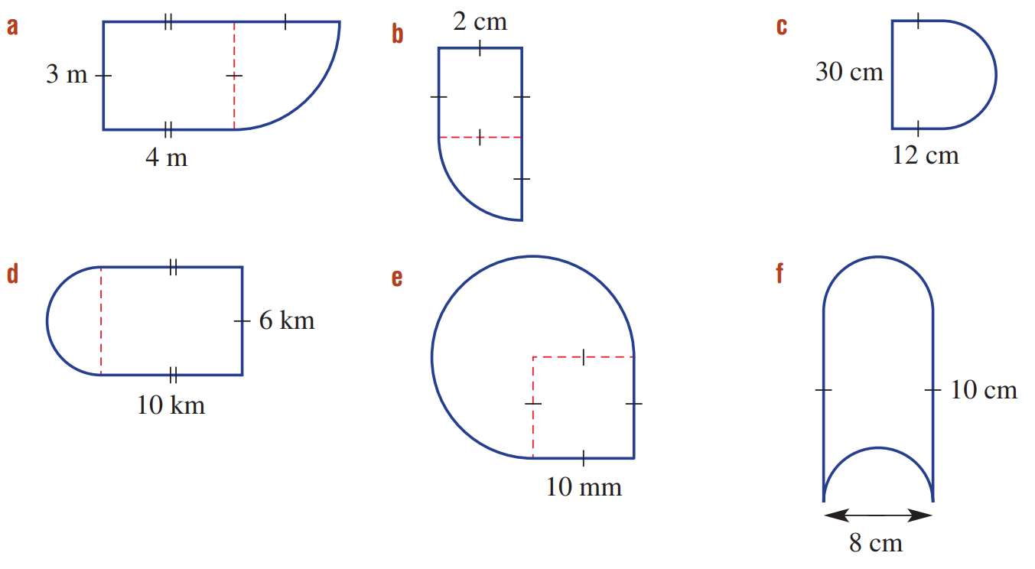
- Explain why you cannot use the formula $P=l+2r$ for this shape.

$l+2r$ is the perimeter of a sector. This is not a sector.
- Calculate the perimeter of these shapes. Answer to 1 d.p.
$$l$$
$$4 m$$
$$3 m$$
$P=3+4+3+4+l$  $18.7$ m | 11.14 cm | 101.12 cm
35.42 km | 67.12 mm | 45.13 cm
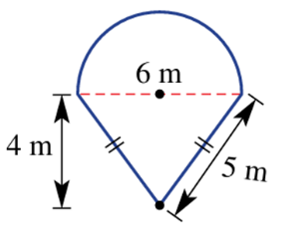  19.42 m | 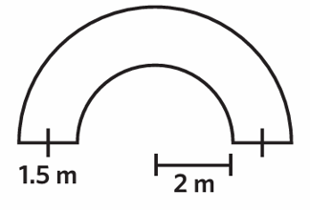  20.28 m | 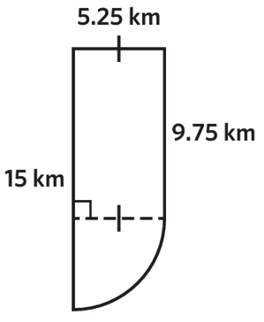  51.21 km

Development
- Calculate the perimeter of these shapes. Leave your answer in exact form in terms of $π$.
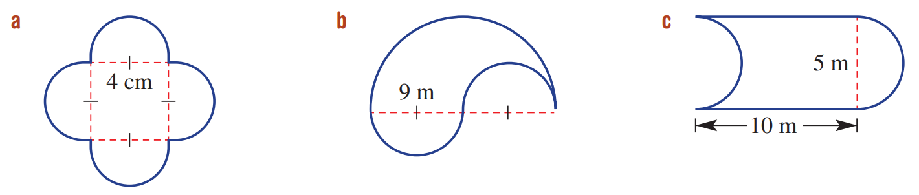  8π cm | 18π m | $20+5π$ m

- Find the exact perimeter of this shape. The curved sections are semicircles.
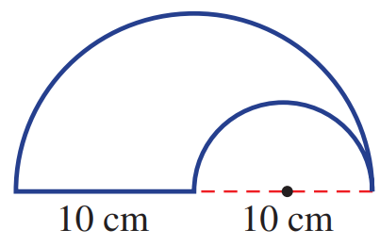

15π + 10 cm
- Find the perimeter of these shapes. Answer to 1 d.p.
30.7 cm | 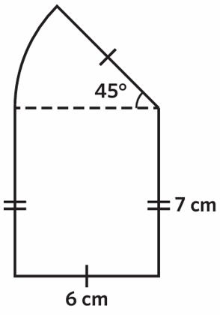  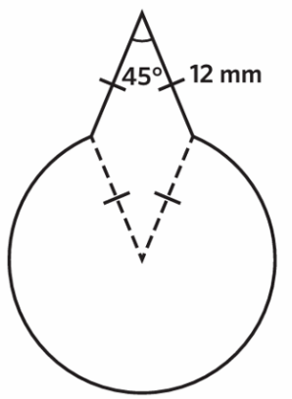  90.0 mm
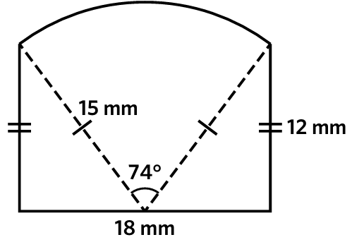  61.37 mm | 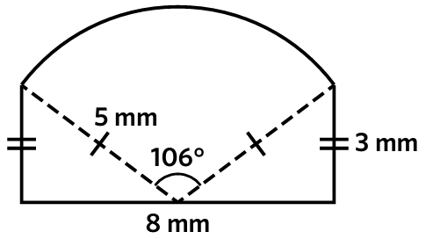  23.3 mm

